|  |  |  |
| --- | --- | --- |
| City of Hendersonville Seal | **CITY OF HENDERSONVILLE** |  |
| **STRATEGIC HOUSING PLAN STEERING COMMMITTEE** |  |
| **2nd Floor Meeting Room | 160 6th Avenue E. | Hendersonville NC 28792** |  |
| **Monday, May 20, 2024 –** **4:00 PM** |  |
|  | |
| **Minutes**  Present: Council Member Lyndsey Simpson, Robert Hooper (WNC Source), Debi Smith, (TDA), Jennifer Duvall (HAC), Hilary Paradise (Land of Sky), Sarah Cosgrove (Builder’s Assoc. of the Blue Ridge), Madeline Offen (Pisgah Legal)  Absent: Council Member Jennifer Hensley, County Commissioner Bill Lapsley (Henderson County), Connie Stewart (Housing Authority) and Carsten Erkel (Partnership for Economic Development    Staff Present: City Manager John Connet, City Attorney Angela Beeker, City Clerk Jill Murray, Communications Manager Allison Justus & Community Development Director Lew Holloway | | |
|  | | |

1. **CALL TO ORDER**

Lyndsey Simpson called the meeting to order at 4:02 p.m. and welcomed those in attendance.

1. **APPROVAL OF AGENDA**

***Debi Smith moved to approve the agenda as presented. A unanimous vote of the Committee Members present followed. Motion carried.***

1. **APPROVAL OF MINUTES**

***Robert Hooper moved to approve the minutes of April 15, 2024, as presented. A unanimous vote of the Committee Members present followed. Motion carried.***

**4**. **NEW BUSINESS**

**A.** **Affordable Housing Summit Debriefing –** *City Staff*

City Attorney Angie Beeker said that the Housing Summit was really good and she wanted to briefly go over Shane’s PowerPoint presentation for those who may have missed it.







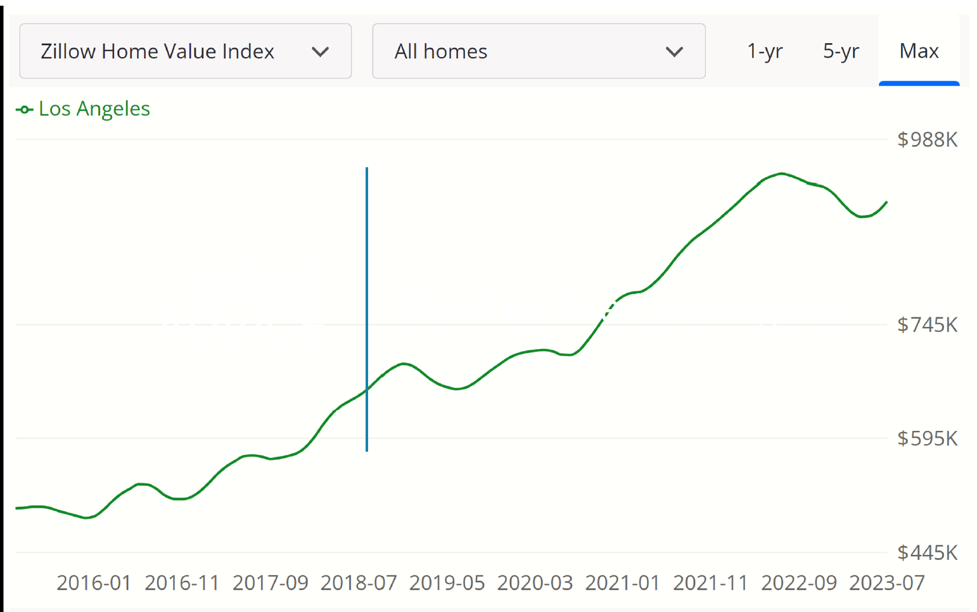

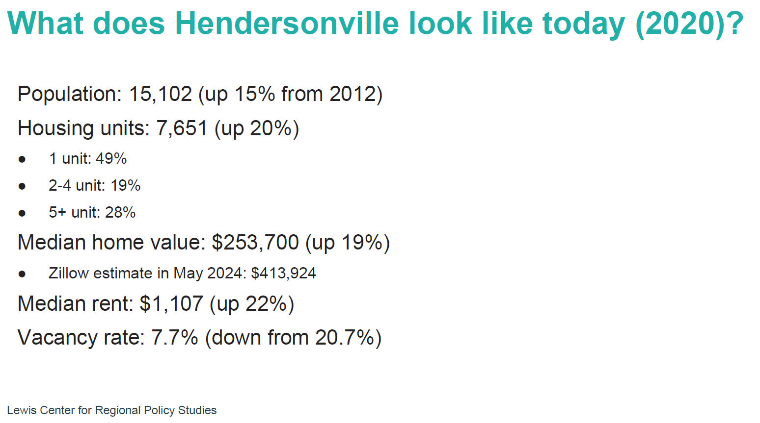

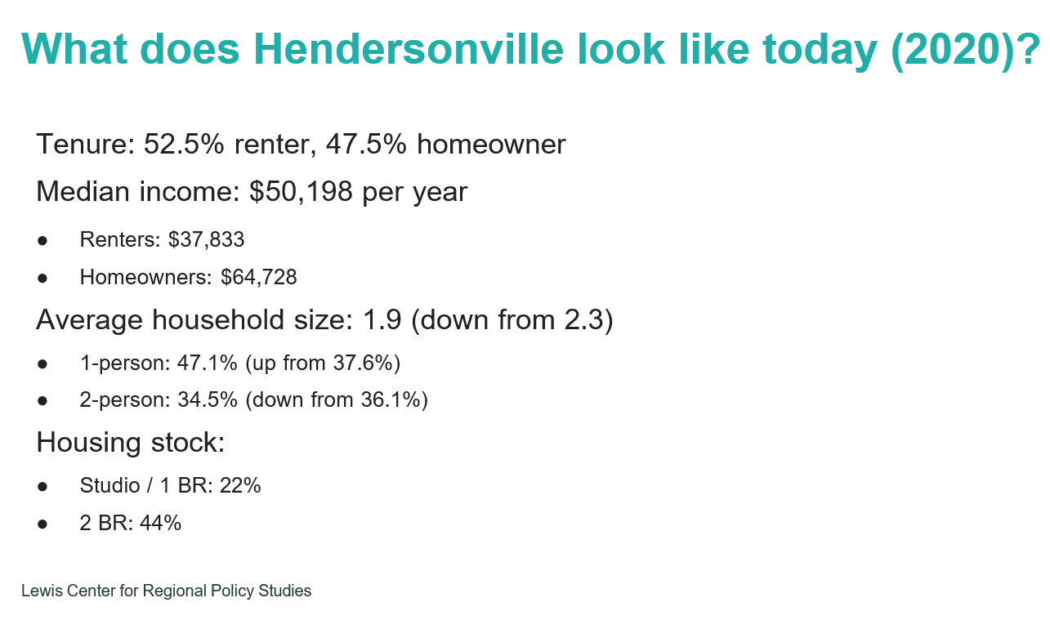

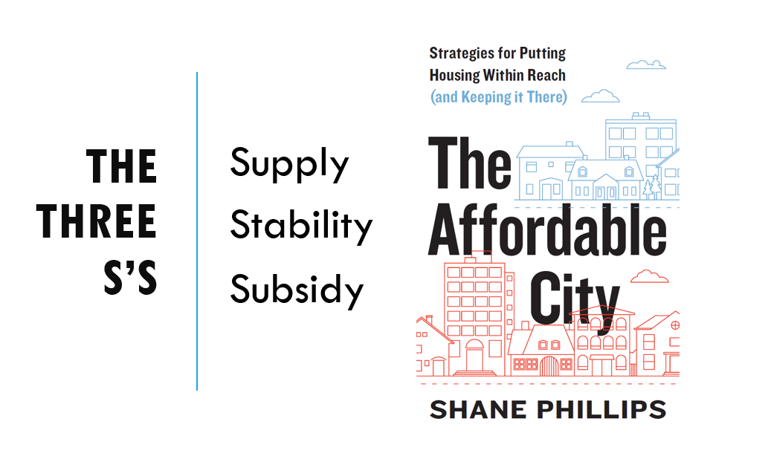

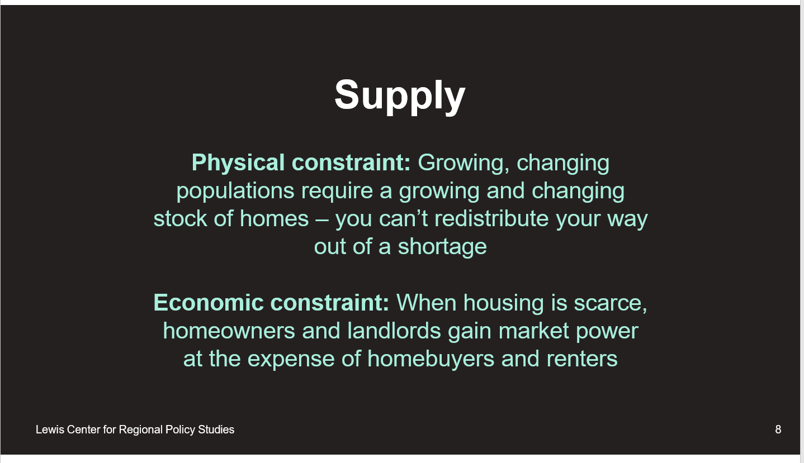

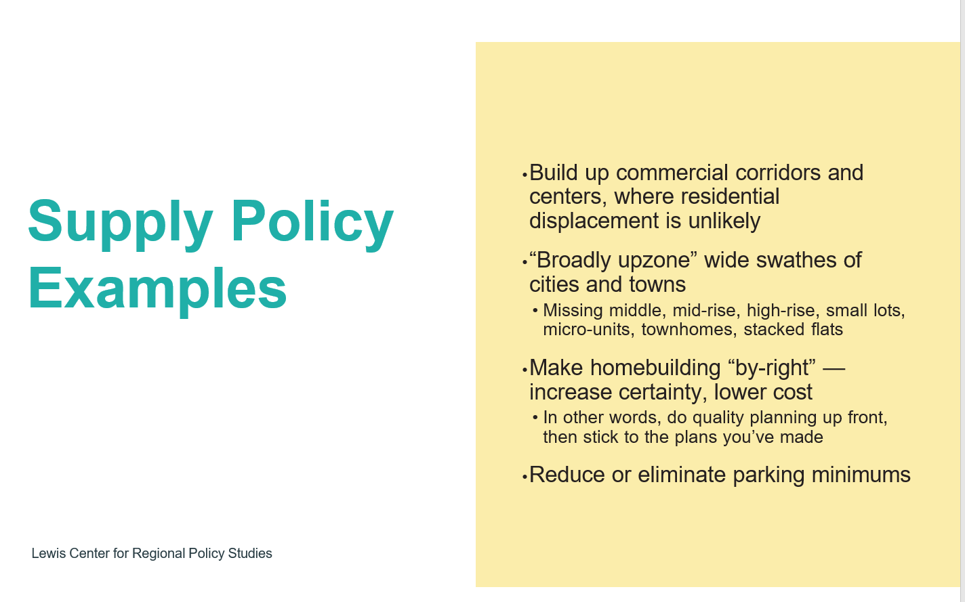

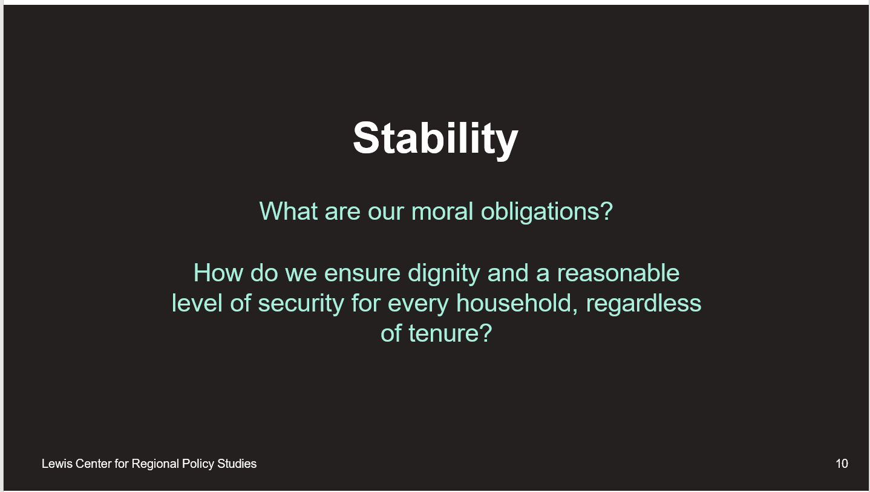

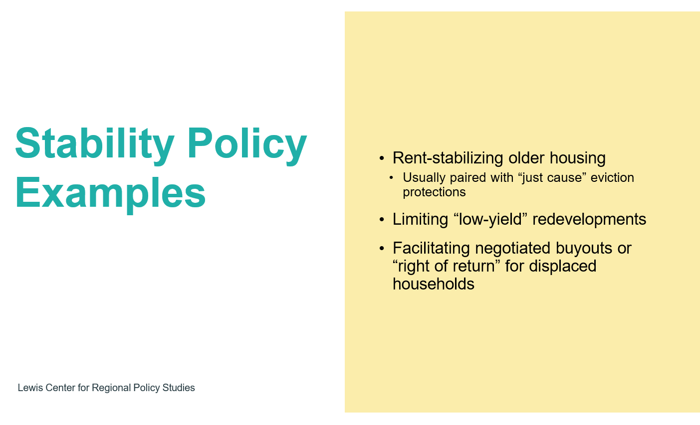

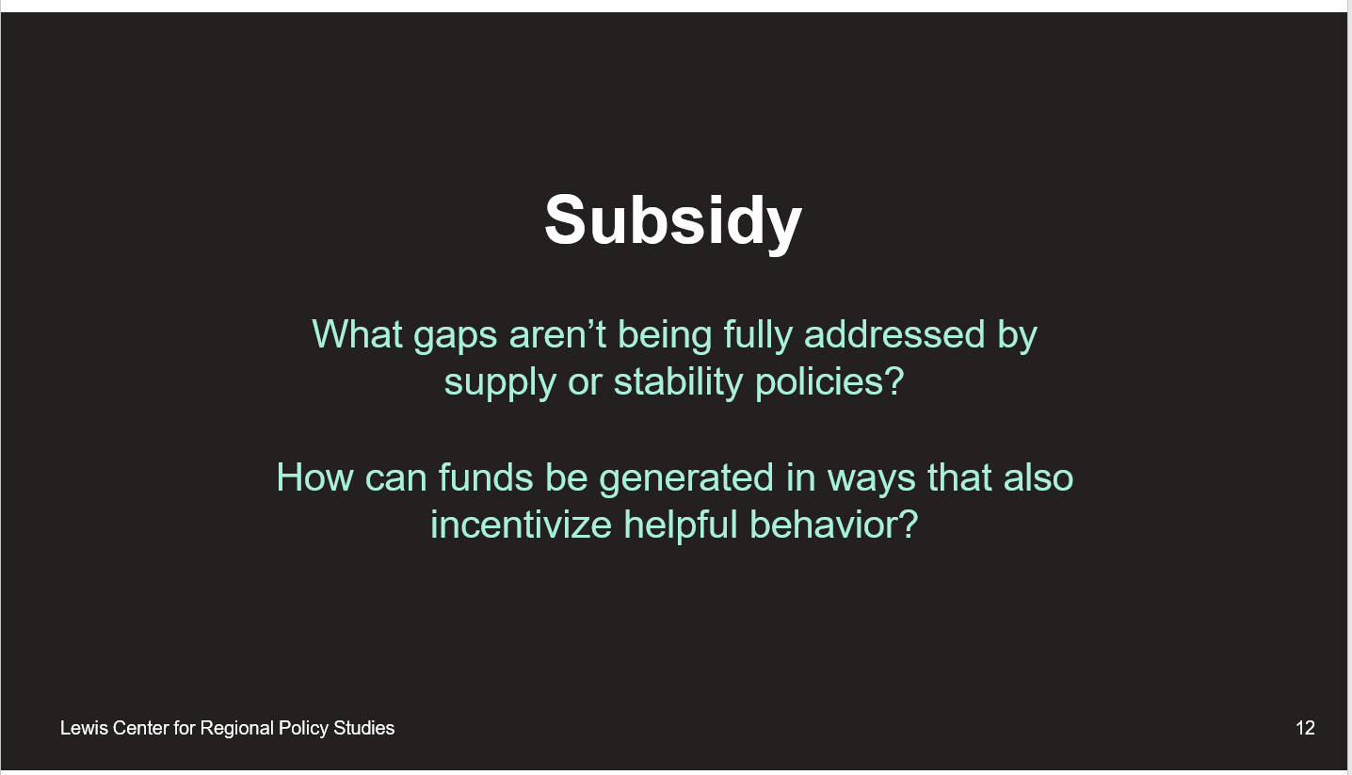

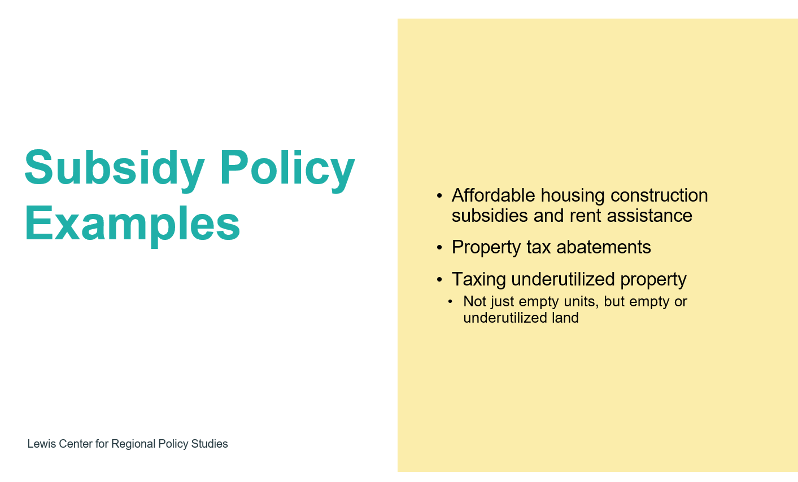



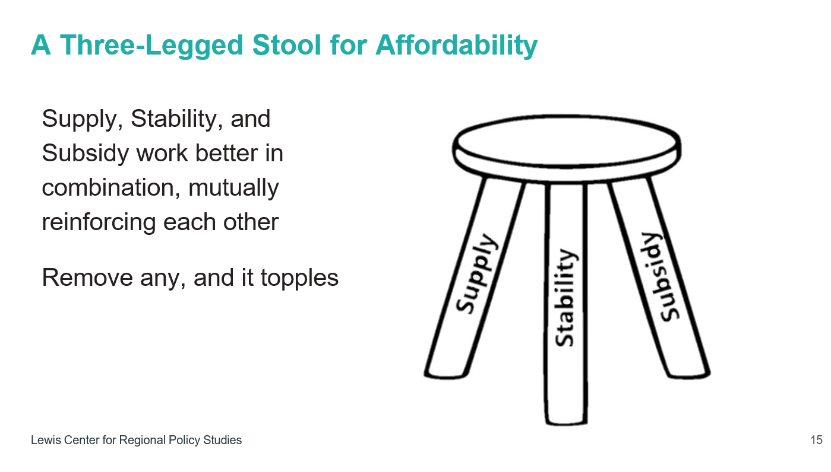

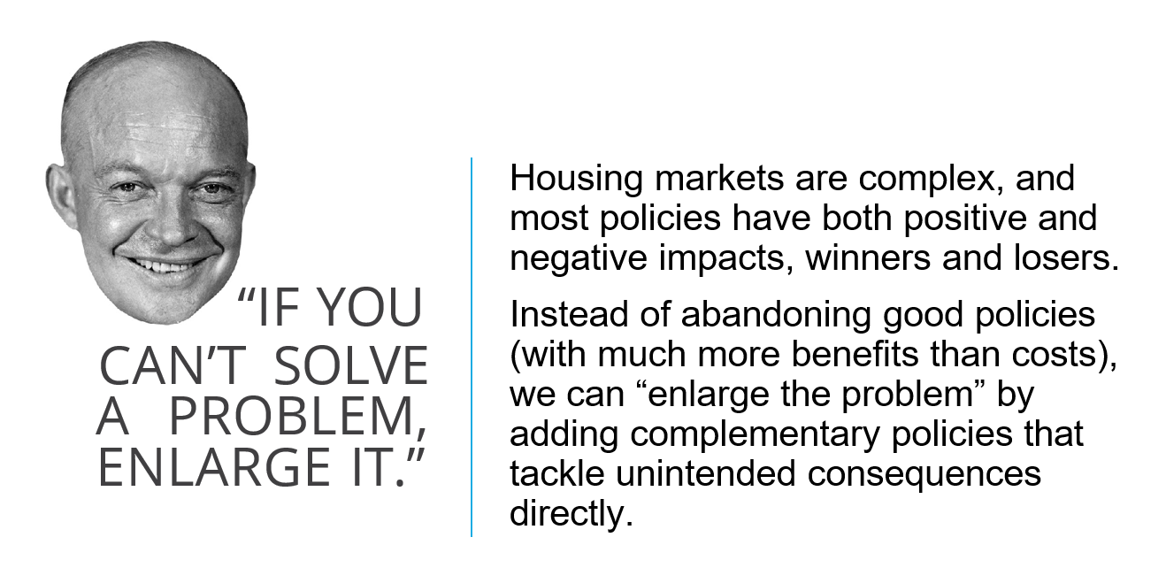

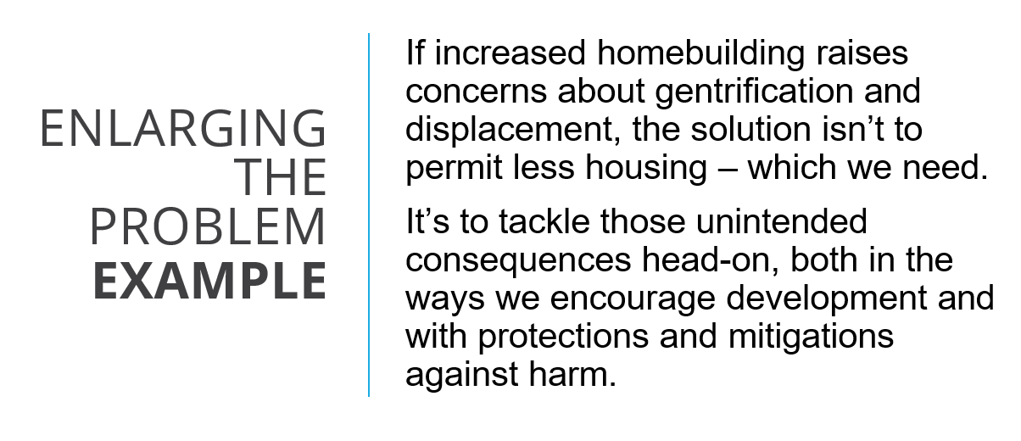

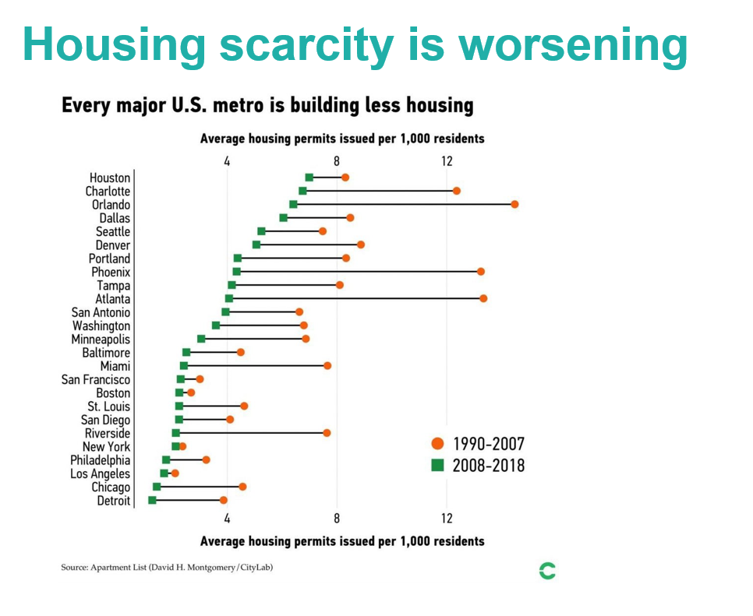

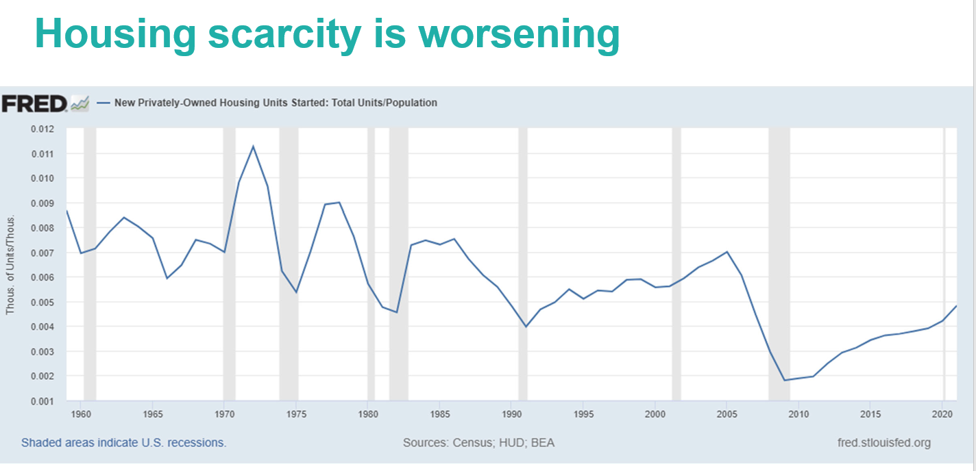

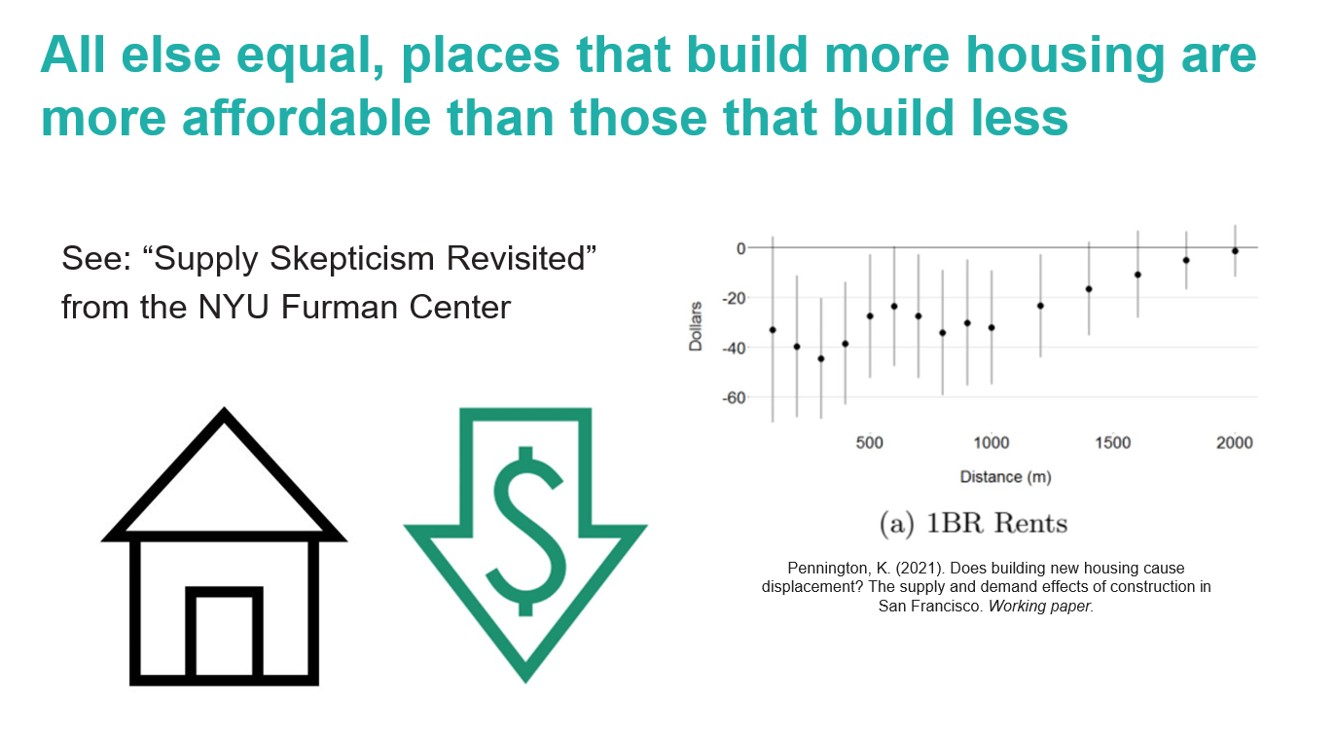

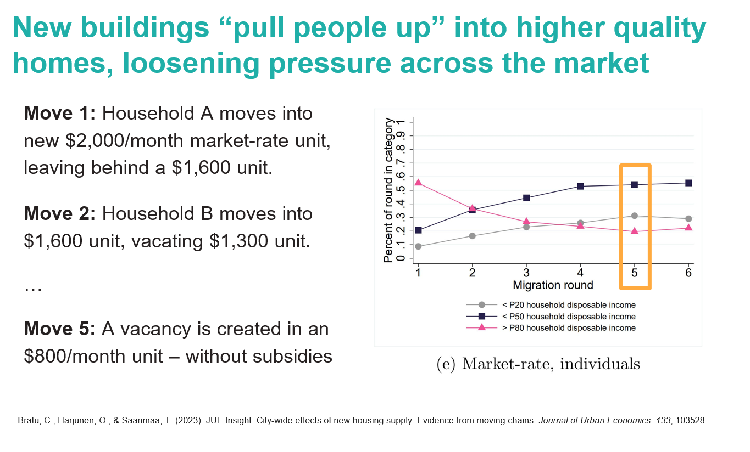

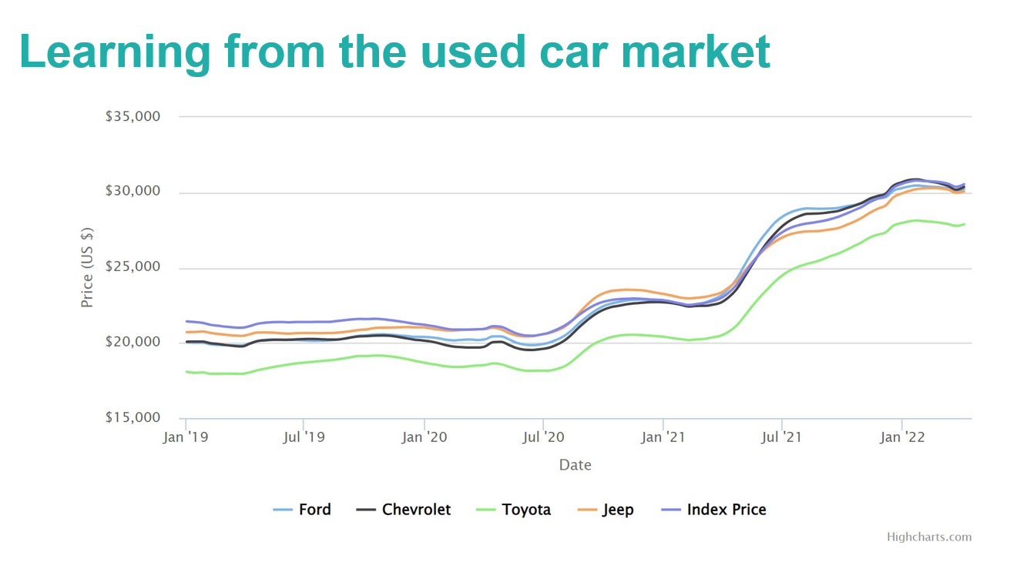

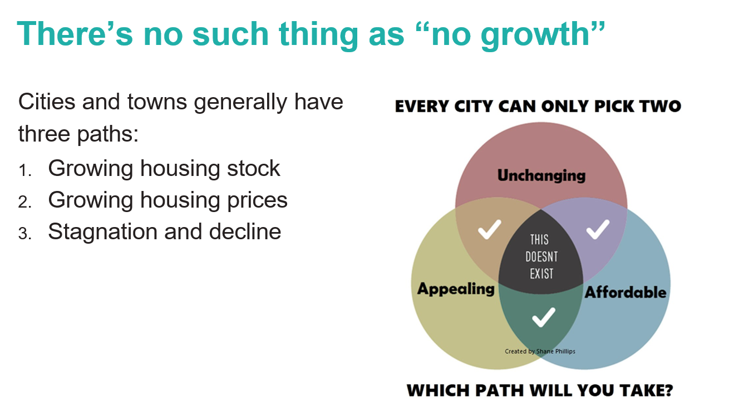



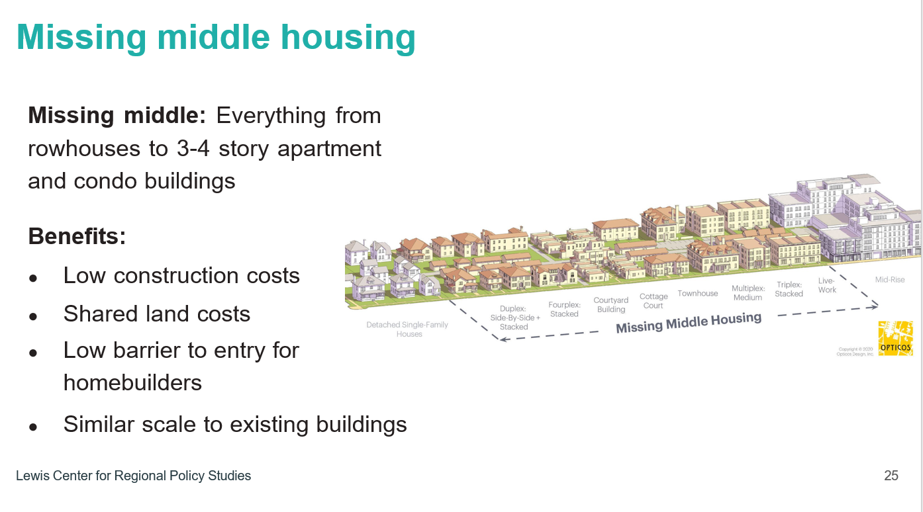

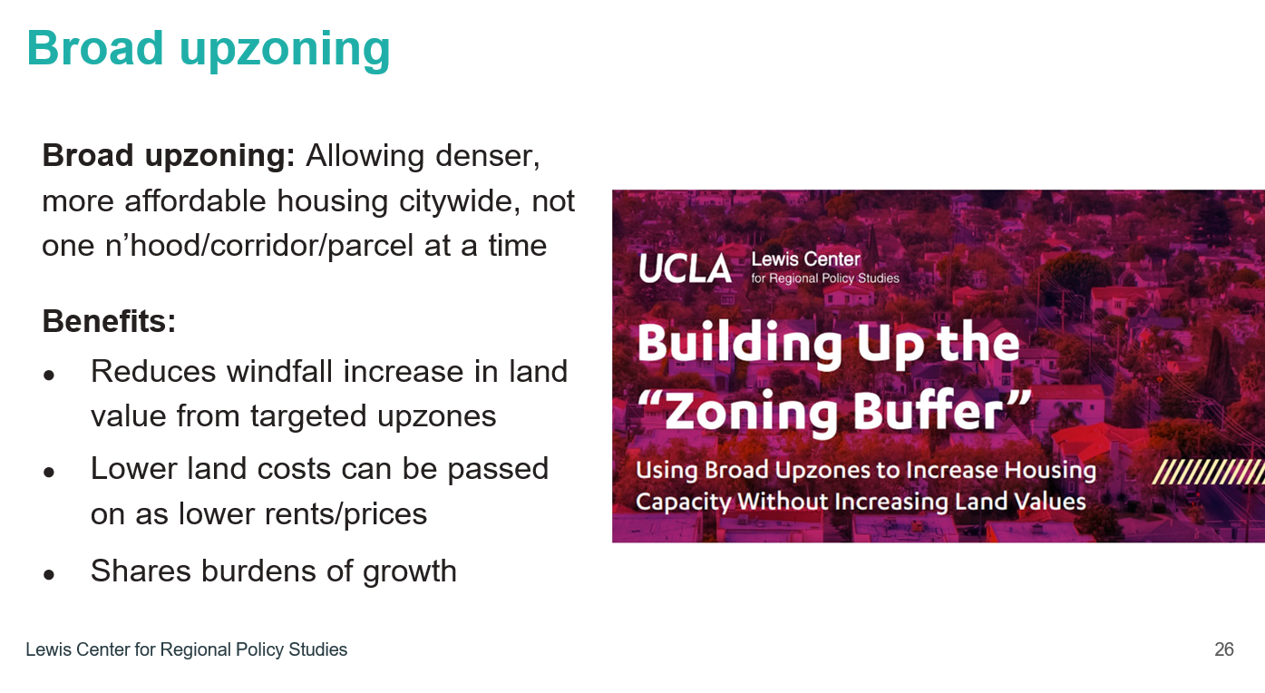

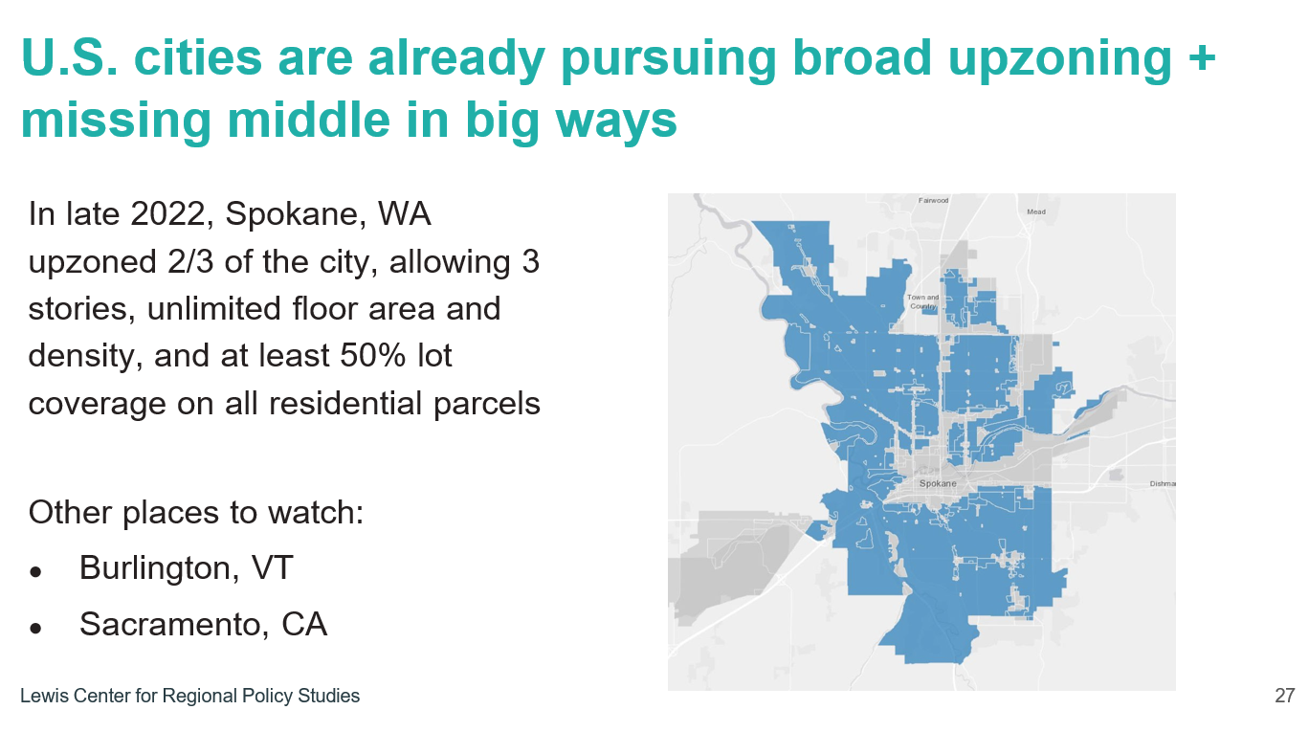

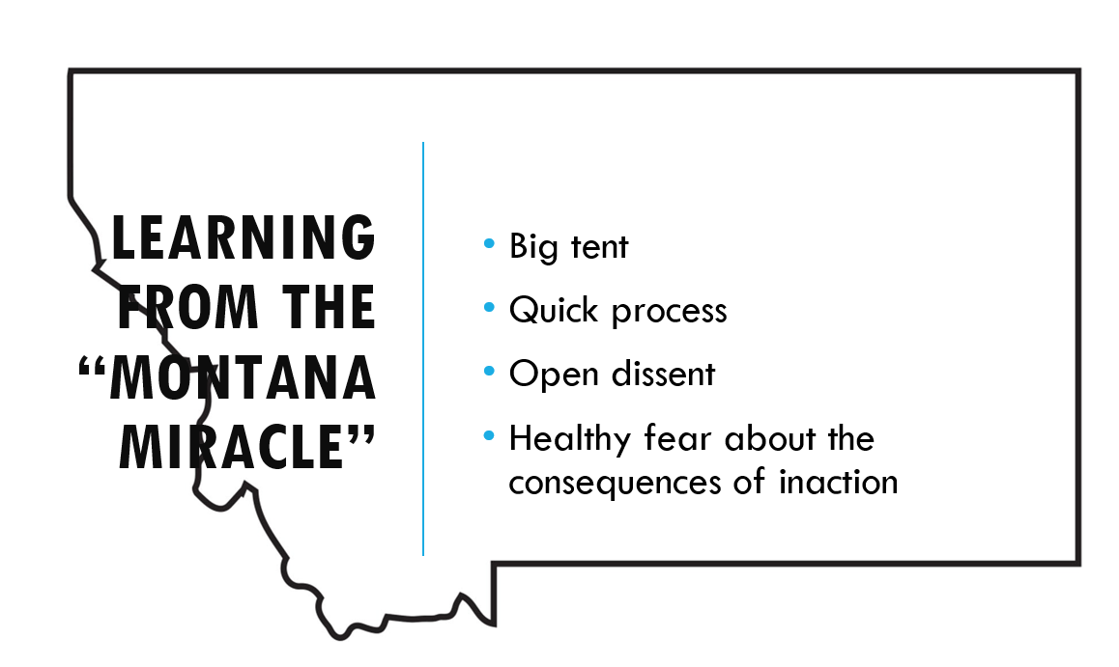

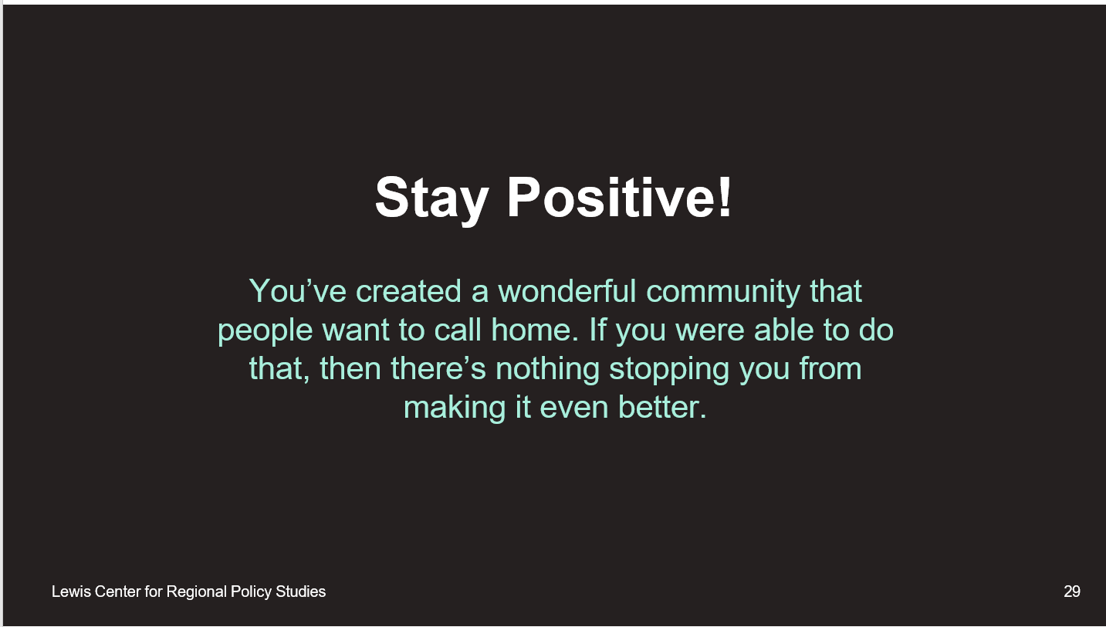



Lyndsey Simpson suggested going around the room and everyone giving their take on his presentation and askoing “what was your lightbulb moment” or something that you wish he would have spoken about. City Attorney Angie Beeker took notes on what everyone said below.

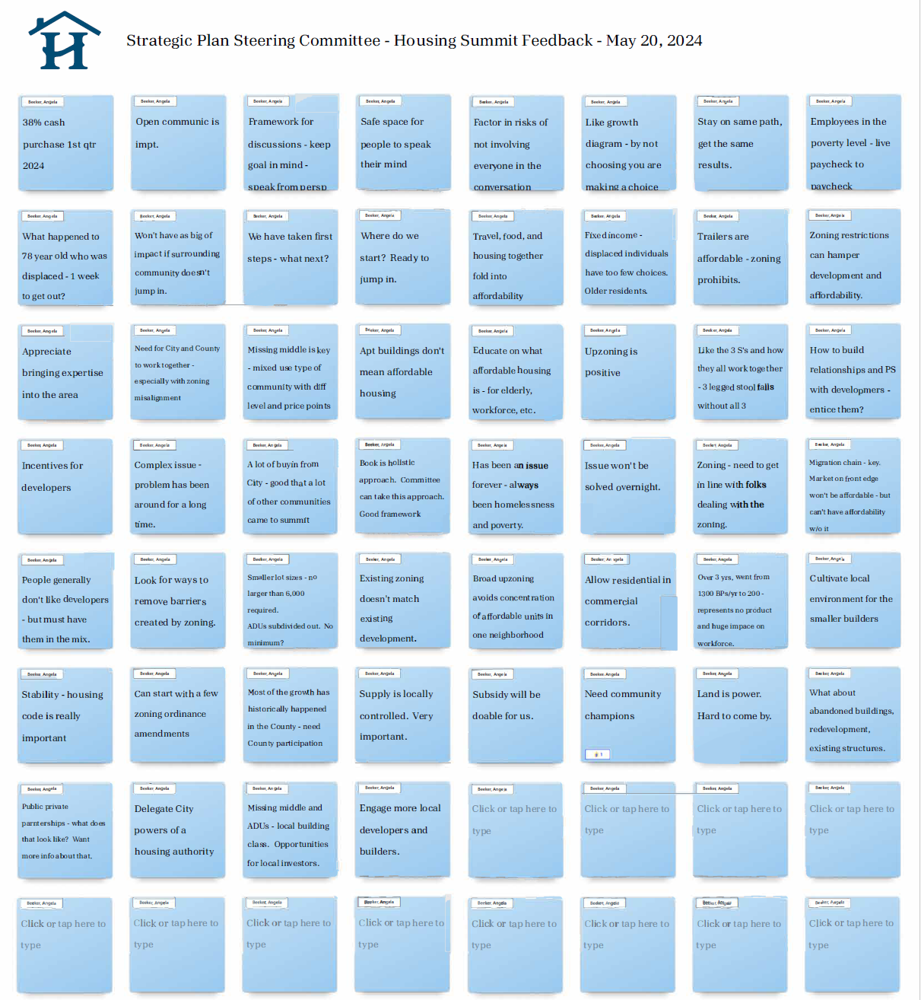

**B.** **Next Steps –** *Council Member Lyndsey Simpson and City Attorney Angie Beeker*

City Attorney Angie Beeker said we need to go through a process and do this in an organized way. City Manager John Connet said he asked the Development Finance Initiative (DFI) to come up with a proposal. We’ve done so many plans and brought in these consultants and when we started thinking about it and the people we have here and knowing that DFI is out there, we asked them to help us with a toolkit. They’ve been doing this in the region and know how it works and we could also get a facilitator to help us with meetings. I felt this would be better than getting some big consulting firm. We could do this with two smaller sub-consultants. So DFI is going to help us and they know the laws.

Angie added that DFI will help us to leverage private funds and she went over the below proposal.

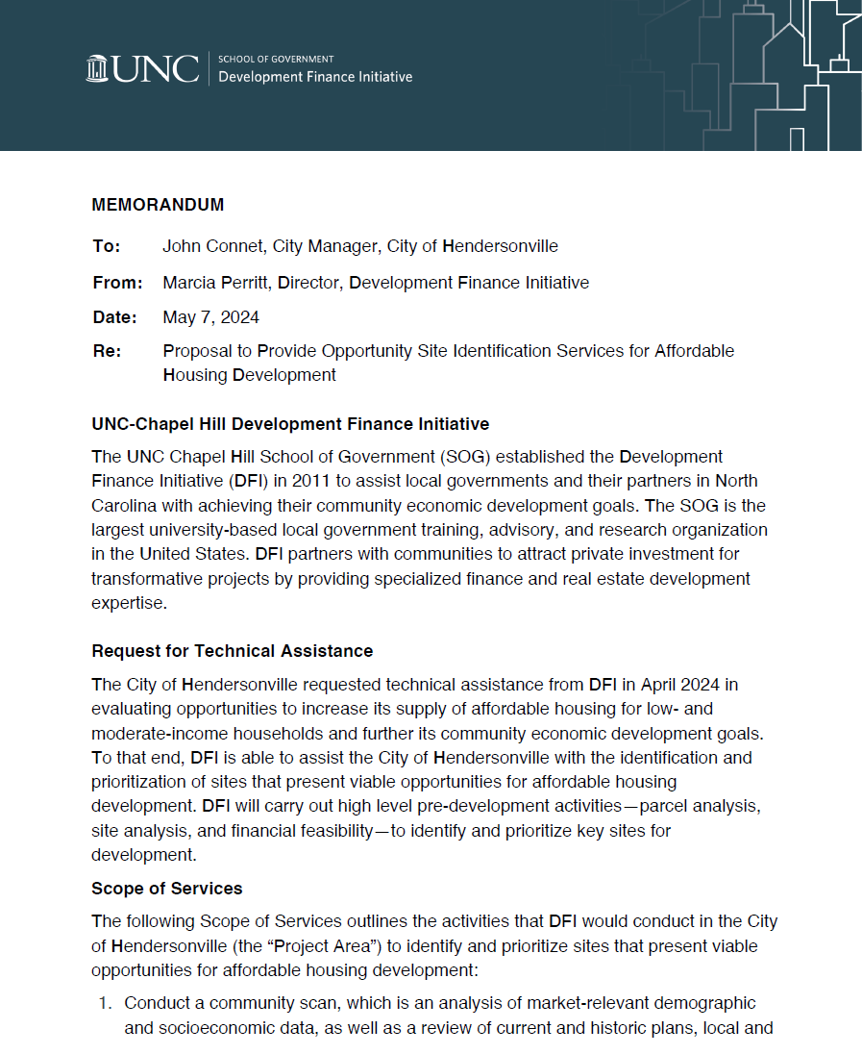

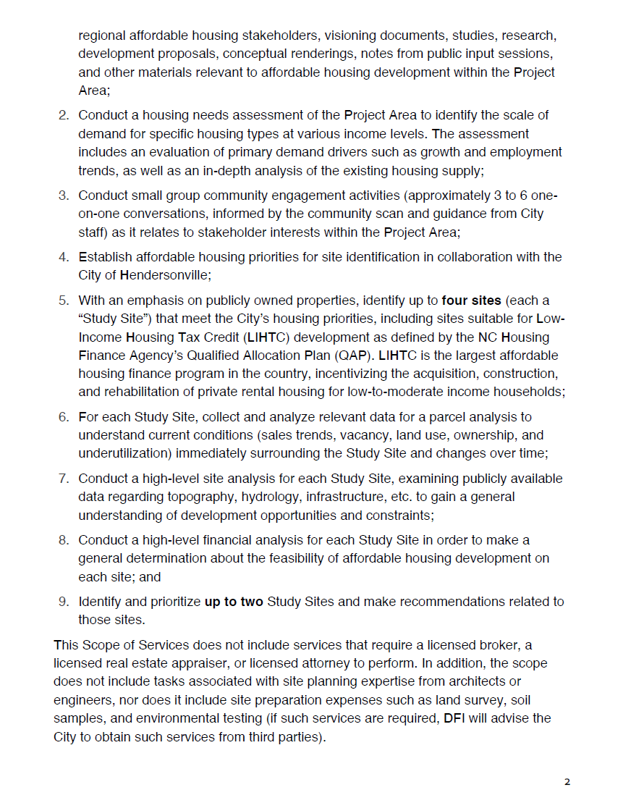

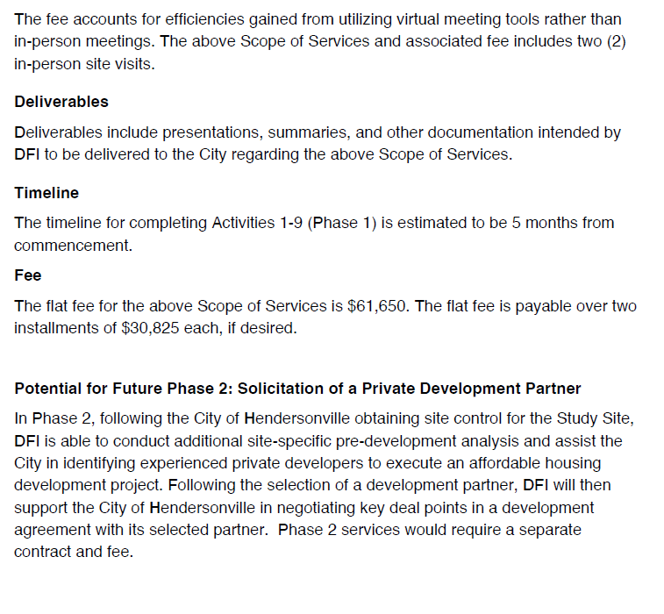***Sarah Cosgrove moved that the committee move all future meetings to the City’s Operation Center on Williams Street and to add “Public Comment” to all future agendas. A unanimous vote of the Committee Members present followed. Motion carried.***

Lyndsey reminded everyone that the next meeting is June 17, 2024 at the Ops Center.

**5. OTHER BUSINESS**

**6.** **ADJOURNMENT**

There being no further business, the meeting was adjourned at 5:28 p.m.

**________________________________________________**

Lyndsey Simpson**,** City Council Member & Chairman

ATTEST:

_____________________________________

Jill Murray, City Clerk