 | CITY OF HENDERSONVILLE
 | STRATEGIC HOUSING PLAN STEERING COMMMITTEE
 | 2nd Floor Meeting Room | 160 6th Avenue E. | Hendersonville NC 28792
 | Monday, April 15, 2024 – 4:00 PM
Minutes
Present: Council Member Lyndsey Simpson, Council Member Jennifer Hensley, County Commissioner Bill Lapsley (Henderson County), Connie Stewart (Housing Authority), Hilary Paradise (Land of Sky), Jennifer Duvall (HAC), and Robert Hooper (WNC Source)

Absent: Sarah Cosgrove (Builder’s Assoc. of the Blue Ridge), Debi Smith (TDA), Council Member Debbie O’Neal-Roundtree, Madeline Offen (Pisgah Legal), And Carsten Erkel (Partnership for Economic Development

Staff Present: City Manager John Connet, City Attorney Angela Beeker & Community Development Director Lew Holloway

- CALL TO ORDER

Jennifer Hensley called the meeting to order at 4:01 p.m. and welcomed those in attendance.

- APPROVAL OF AGENDA AND MINUTES

Jennifer Duvall, seconded by Robert Hooper, to approve the agenda and minutes of March 18, 2024, as presented. A unanimous vote of the Committee Members present followed. Motion carried.

3. OLD BUSINESS

A. Update on Affordable Housing Summit – City Attorney Angie Beeker, Community Development Director Lew Holloway, and City Manager John Connet
City Attorney Angie Beeker explained that Shane Phillips will be coming here to Hendersonville on Thursday, May 16th (in the evening at Hendersonville High School Auditorium from 5:30pm-7:45pm) and Friday May 17th at the City Operations Center where we can have breakout sessions with smaller groups with some of our local non-profit service providers, business industrial community, city council members and city staff. City Manager Connet said they will get a “save-the-date” letter out to everyone once we nail down the school auditorium. Ms. Beeker added that you have another Strategic Housing Plan Steering Committee Meeting on the following Monday, May 20th so you can either use these meetings as your meeting or you can still have the meeting on the 20th to discuss everything that you learned from Shane Phillips.

4. OLD BUSINESS

A. Duke N.C. Leadership Forum Housing Review – Jennifer Hensley, Council Member
Council Member Hensley explained that a couple of years ago, her and Commissioner Lapsley got to participate in a leadership forum. They do these all over the state in different regions and we met for 6 months or so and this was our topic “How Can We Increase Access to Adequate Housing in Western North Carolina”. This group was made of up non-profit leaders, local leaders, local senator to the Asheville area and its geared to be a group of non-partisan people to have very raw discussions and I think what I learned the most is that everybody has the same goal in mind and we all have different ways of getting there. So we came up with some guidelines and she presented the following PowerPoint presentation.
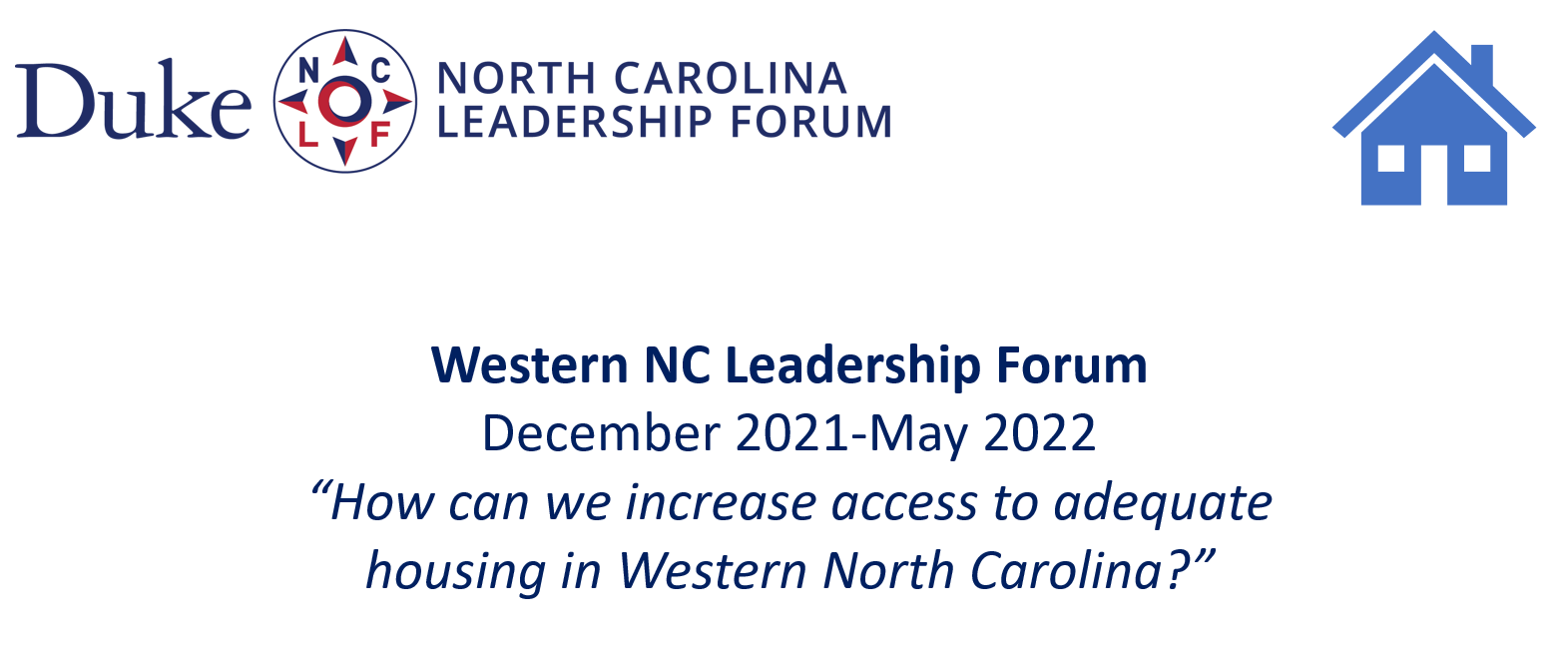

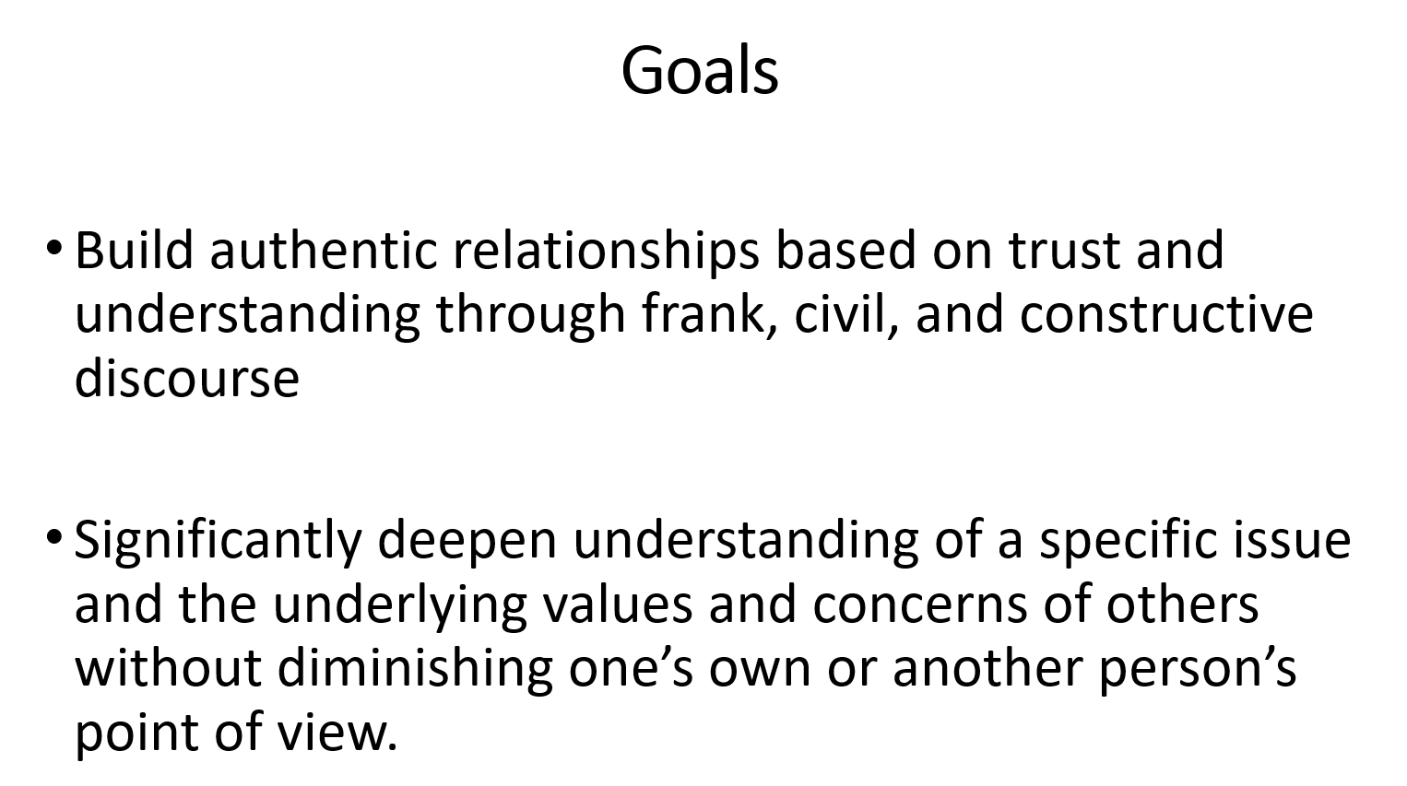
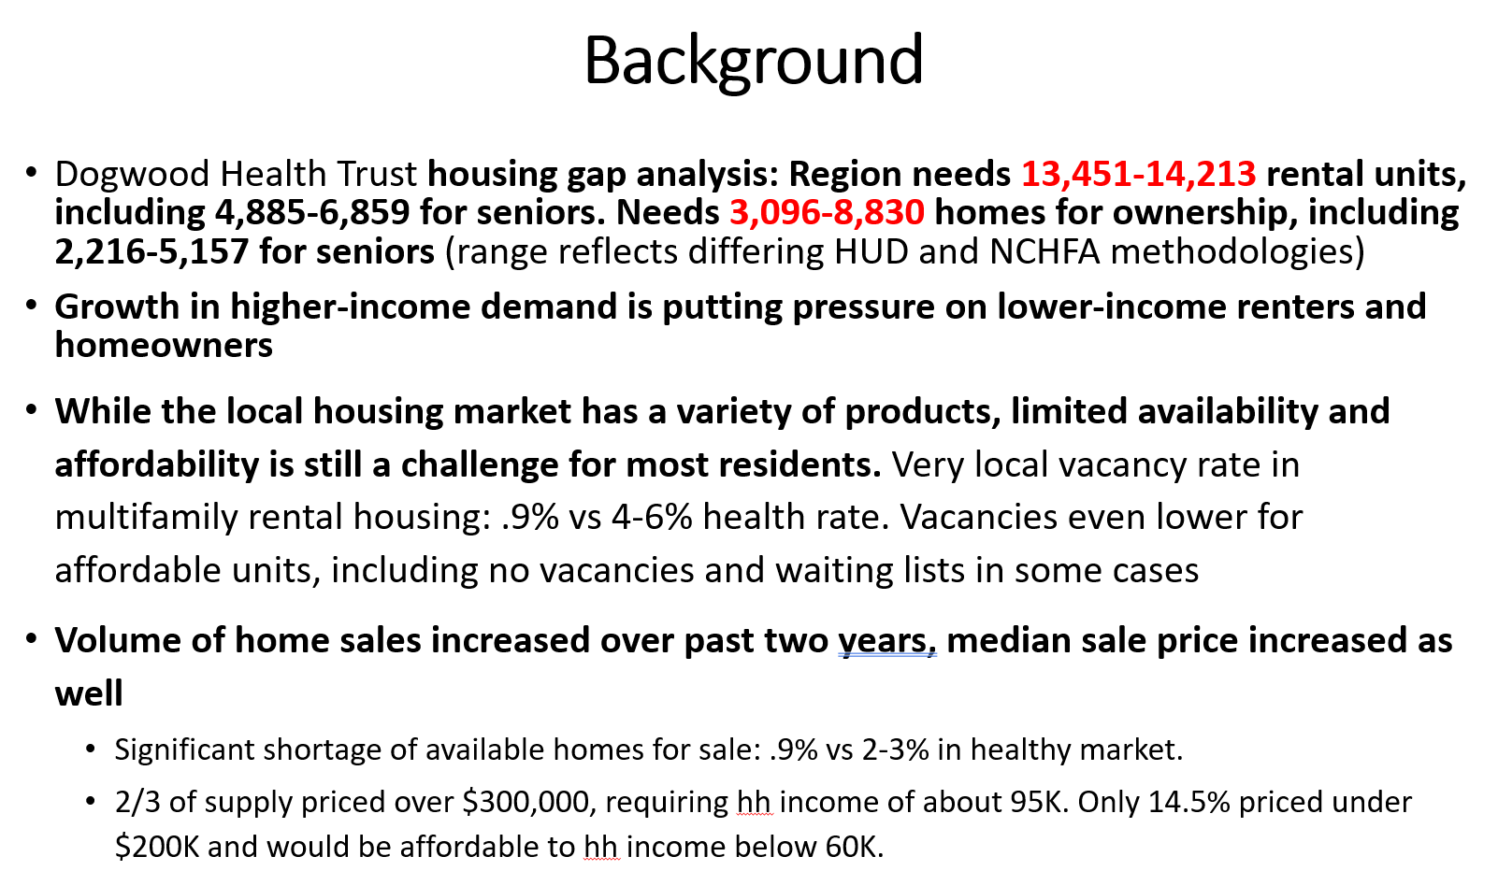
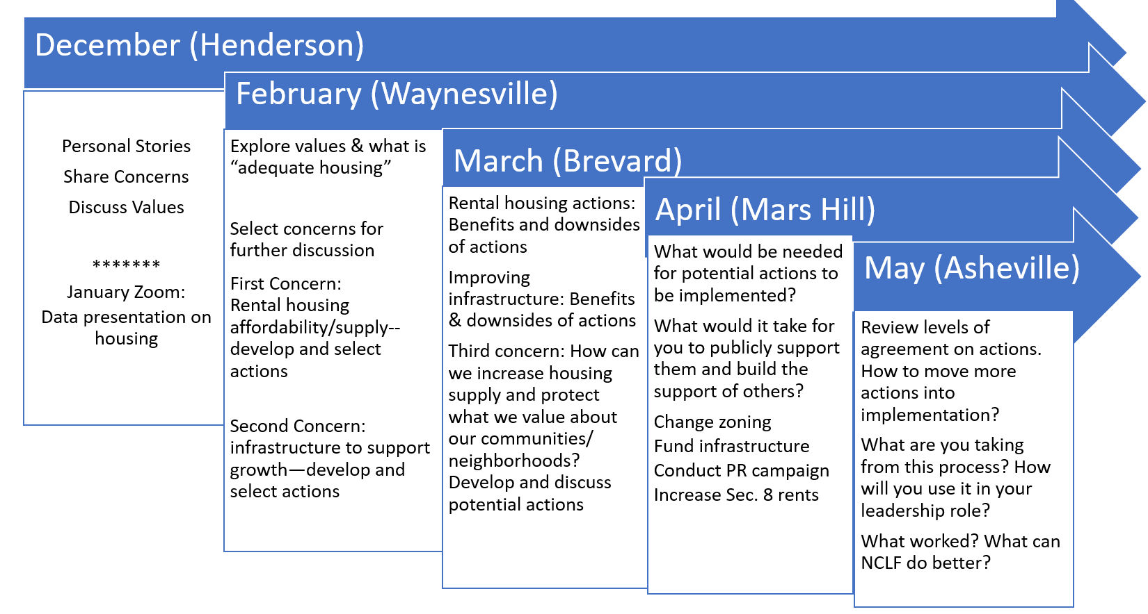
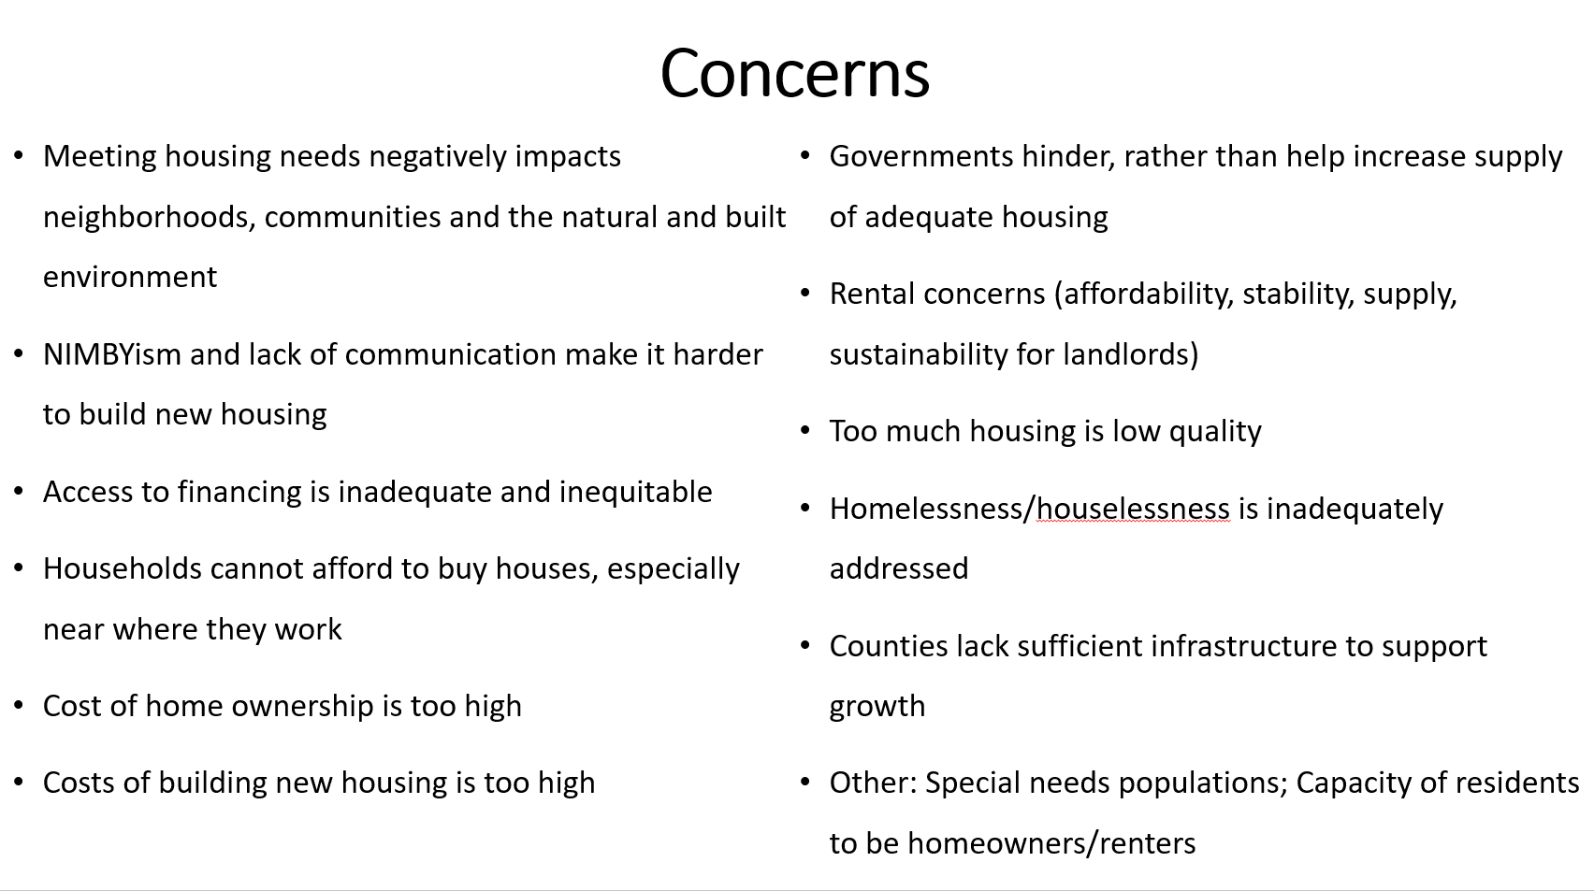
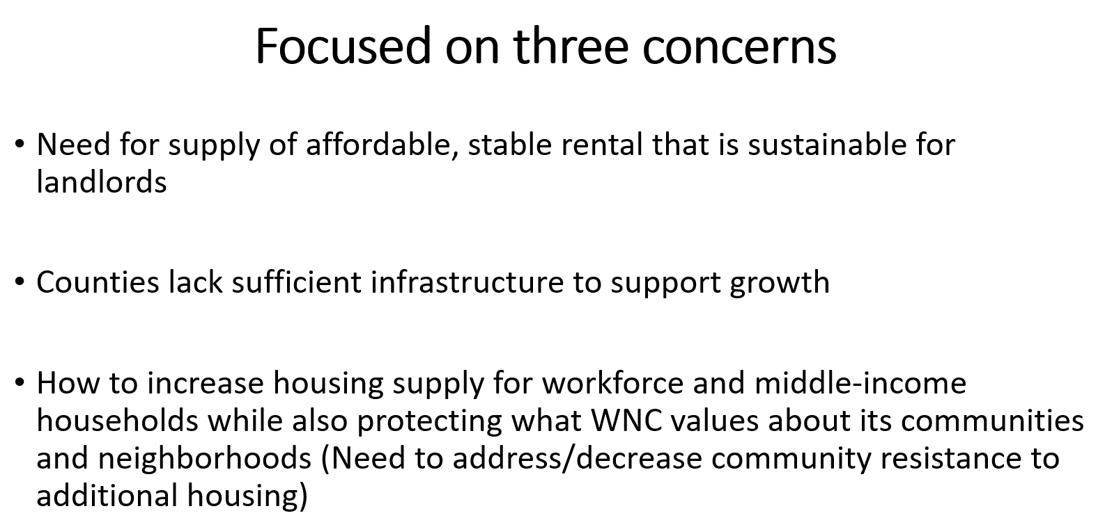
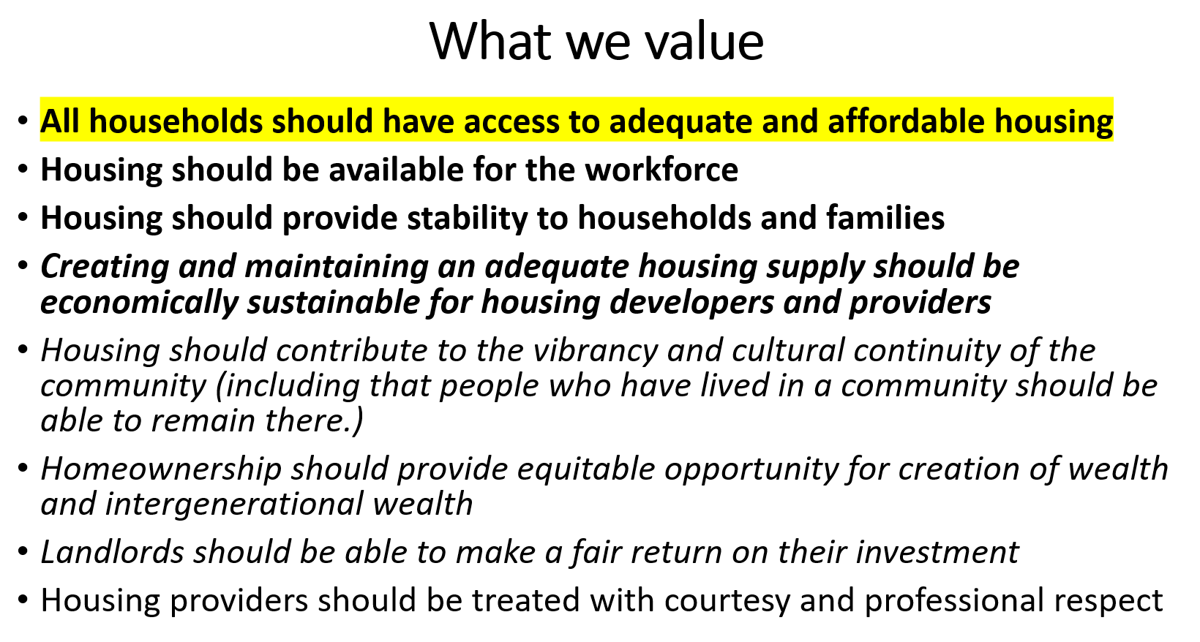
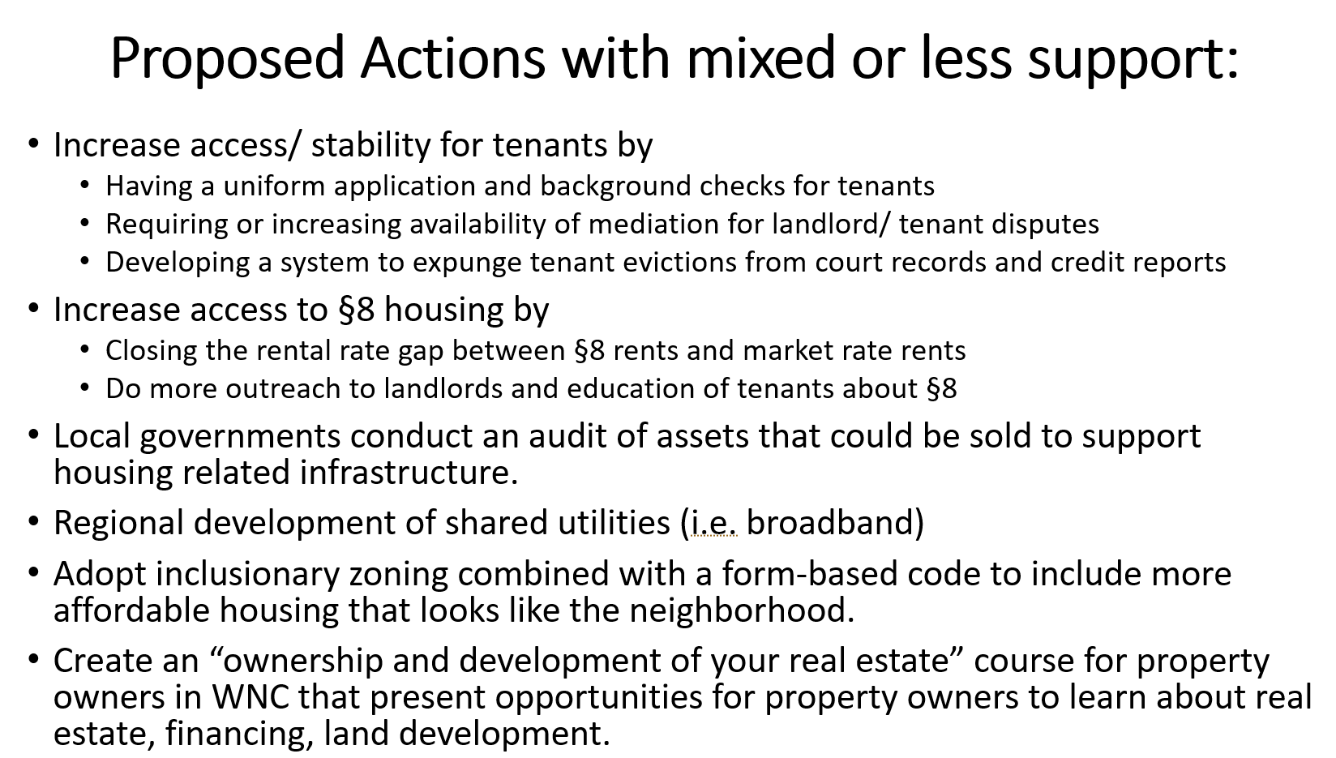
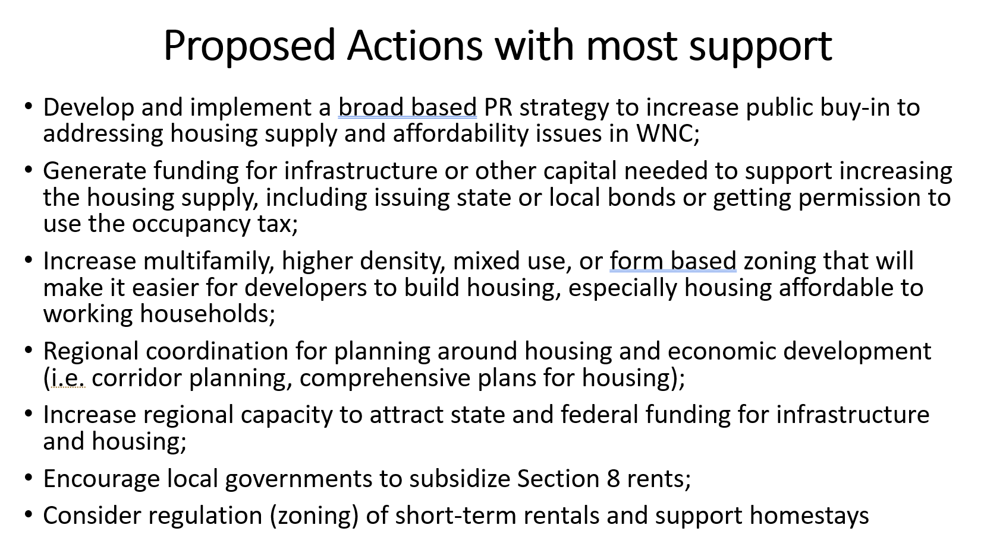
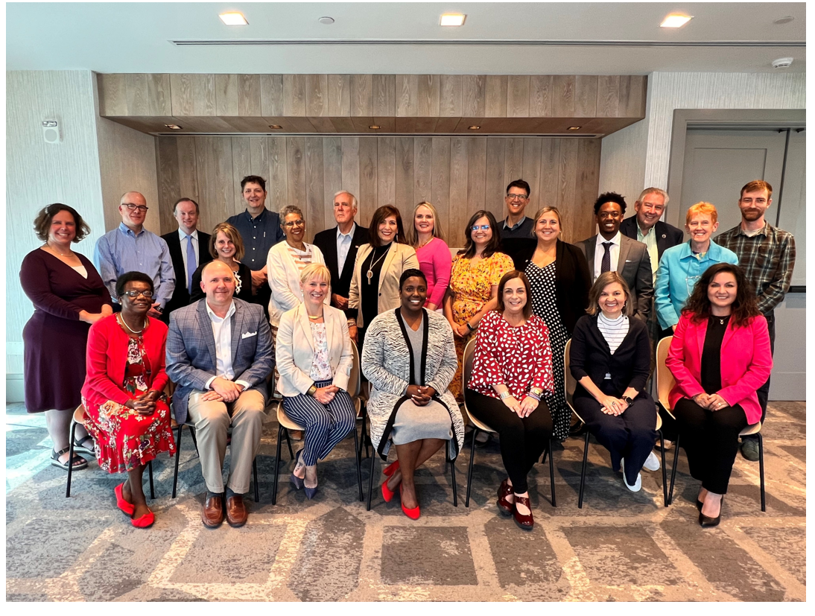
I felt like we learned a ton of things and we had a follow up meeting in Raleigh this fall and we went over everything that we learned and I felt like it gave us a really good guidelines of what we can do, what we’re able to do, what we should be doing and so parts of those plans would be good for us to look at so that we can develop actionable items within this group and not try to reinvent the wheel. Also using the information that Angie is providing us and getting the study done, those are all going to provide tools for us to move forward.
B. Review of 2020 Bowen Housing Study – John Connet, City Manager
City Manager Connet presented the following PowerPoint presentation that was given to Council in March 2022, but the data is from 2020. The Dogwood Group will be updating this study in 2025.


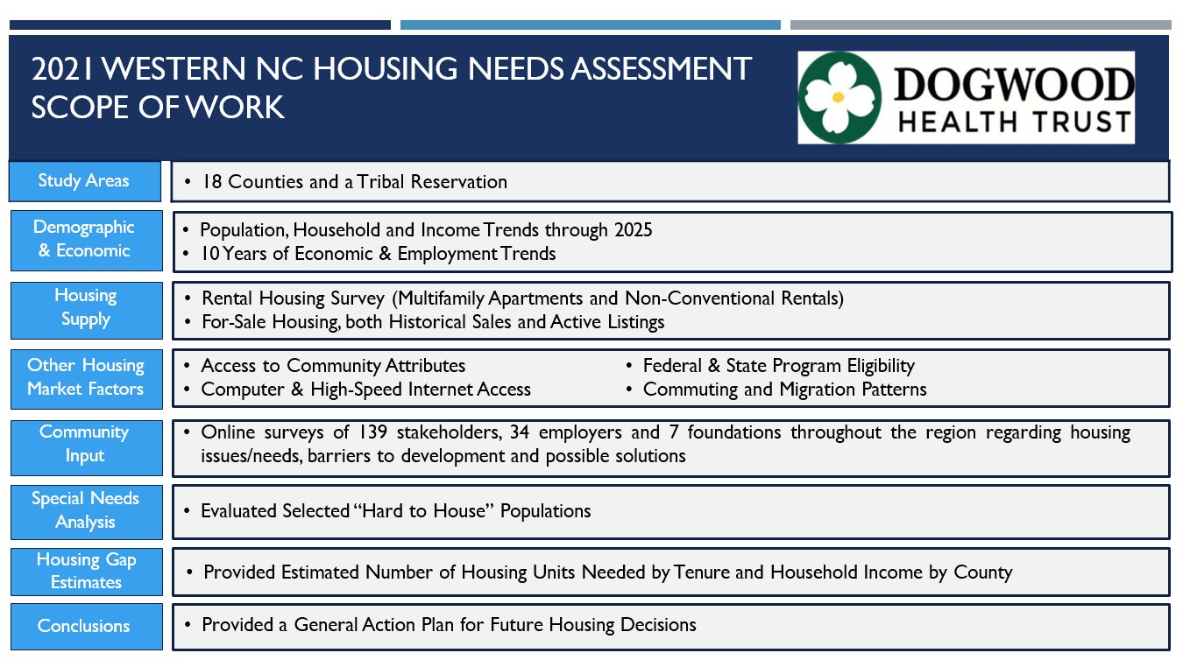
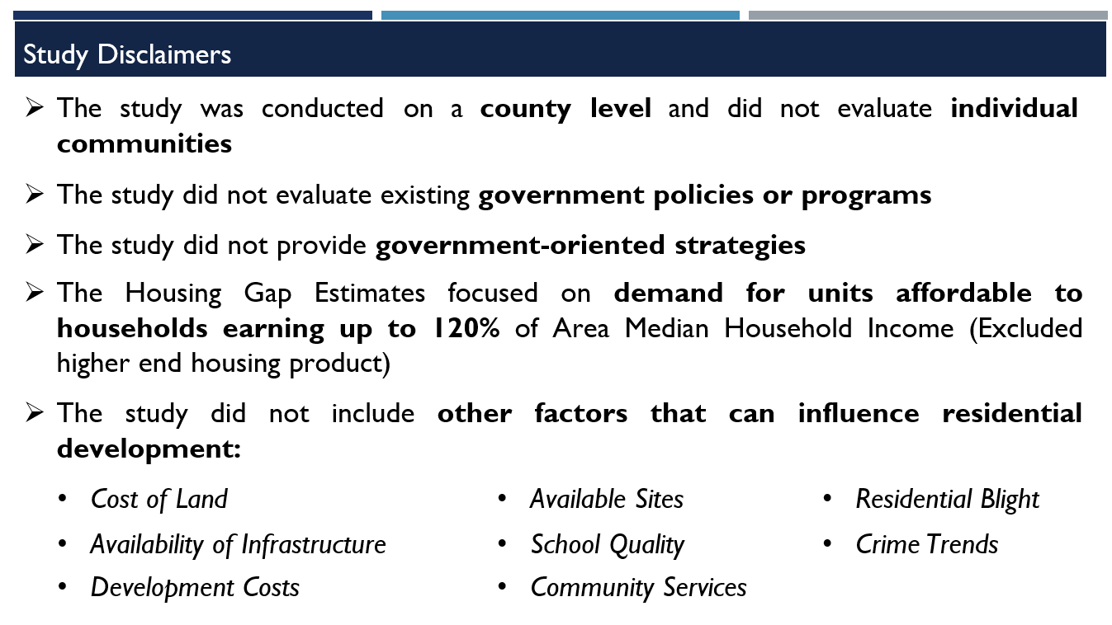
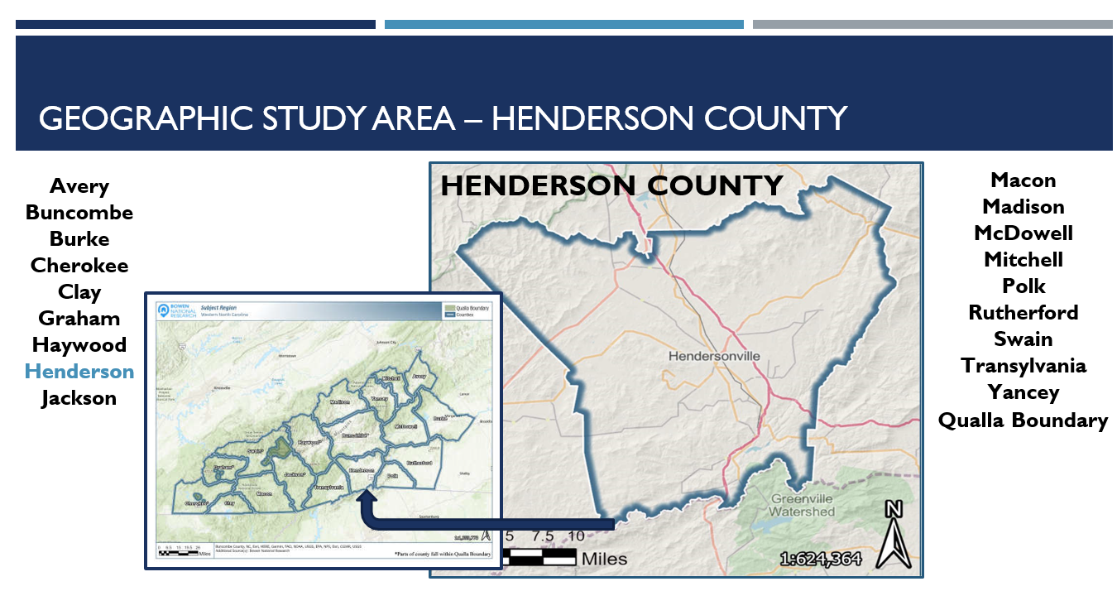
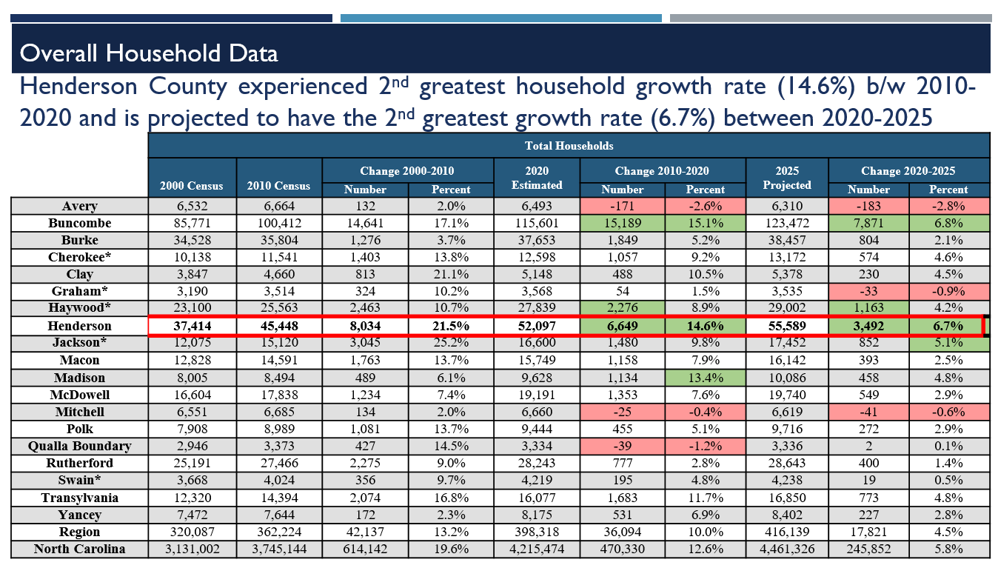
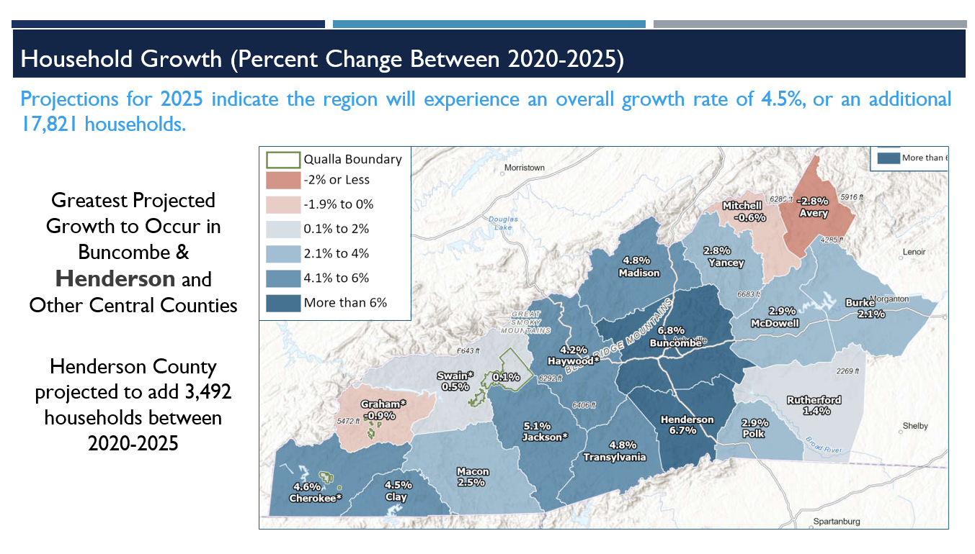
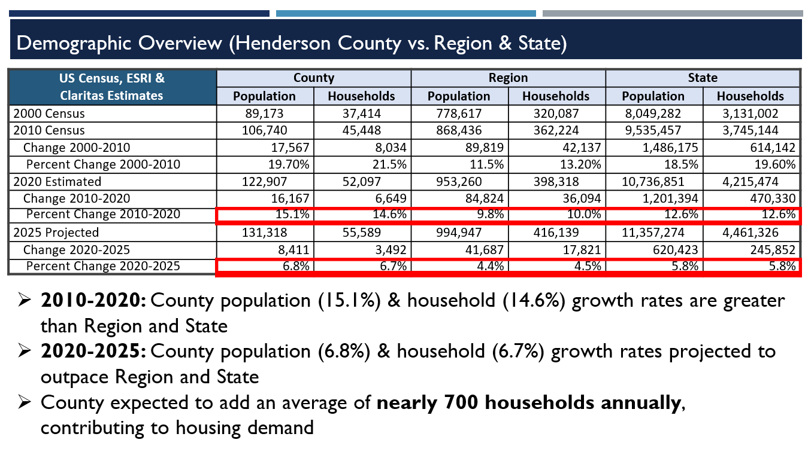
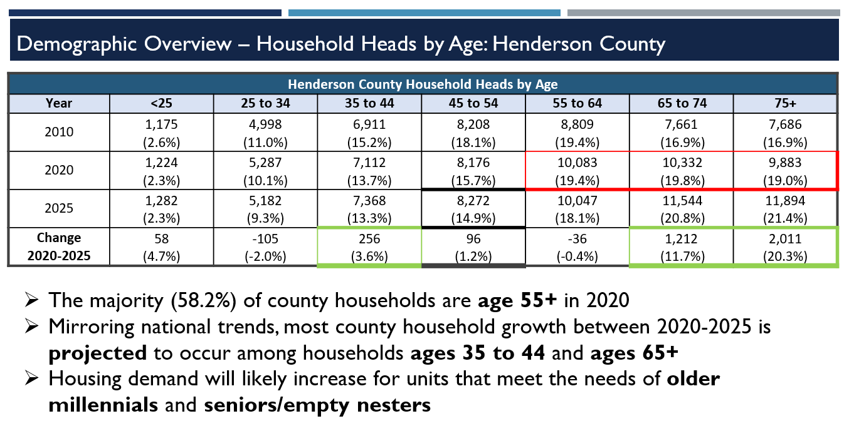
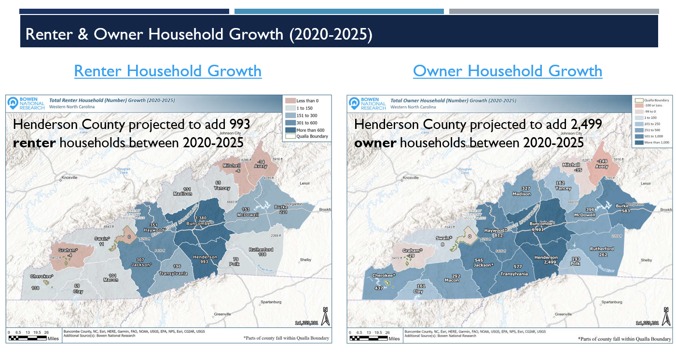
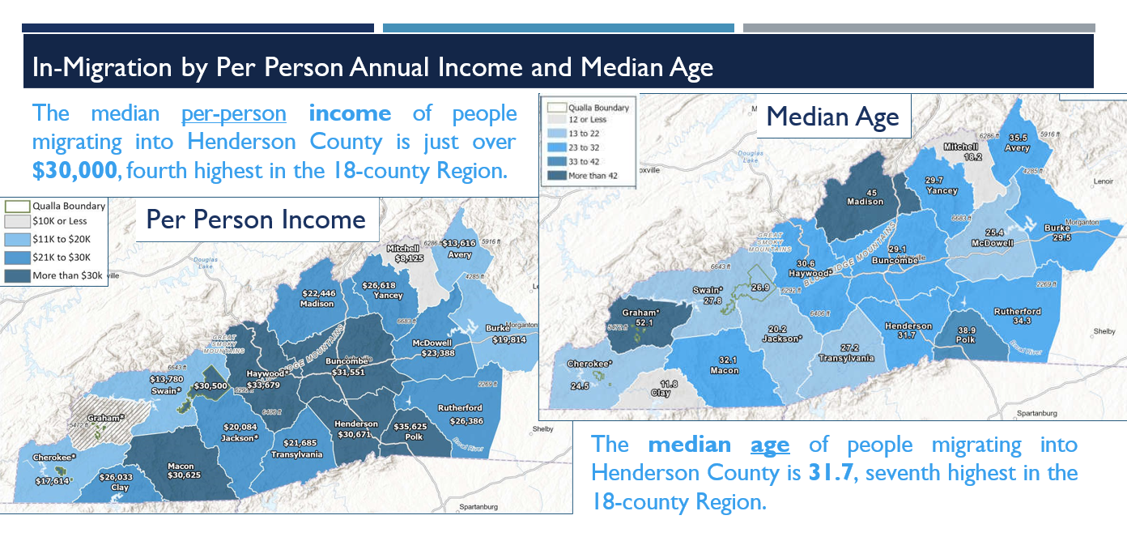
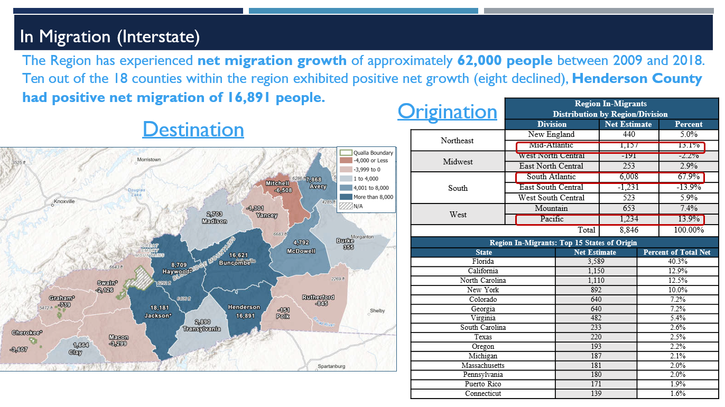
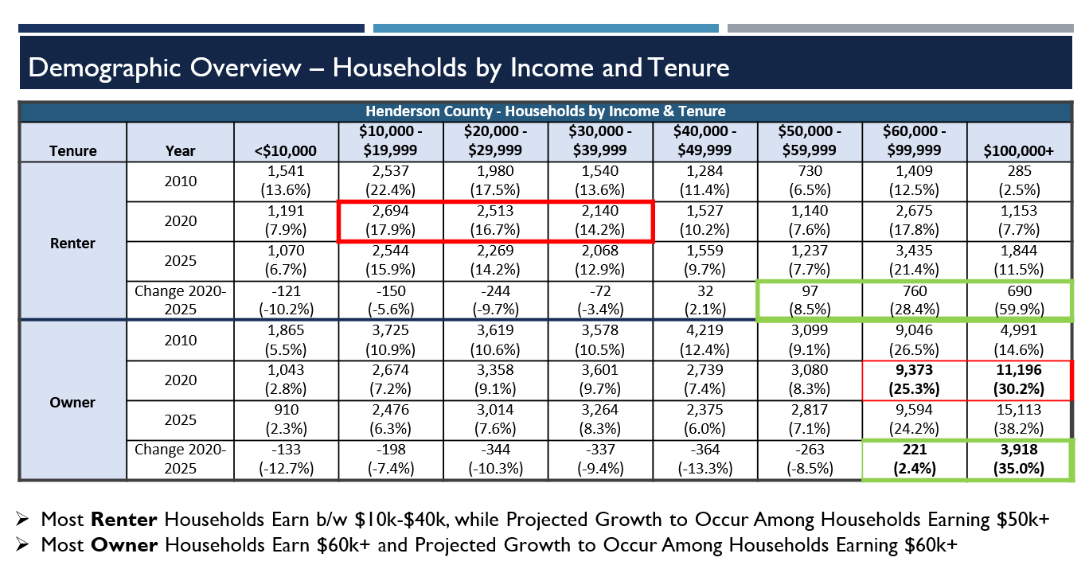
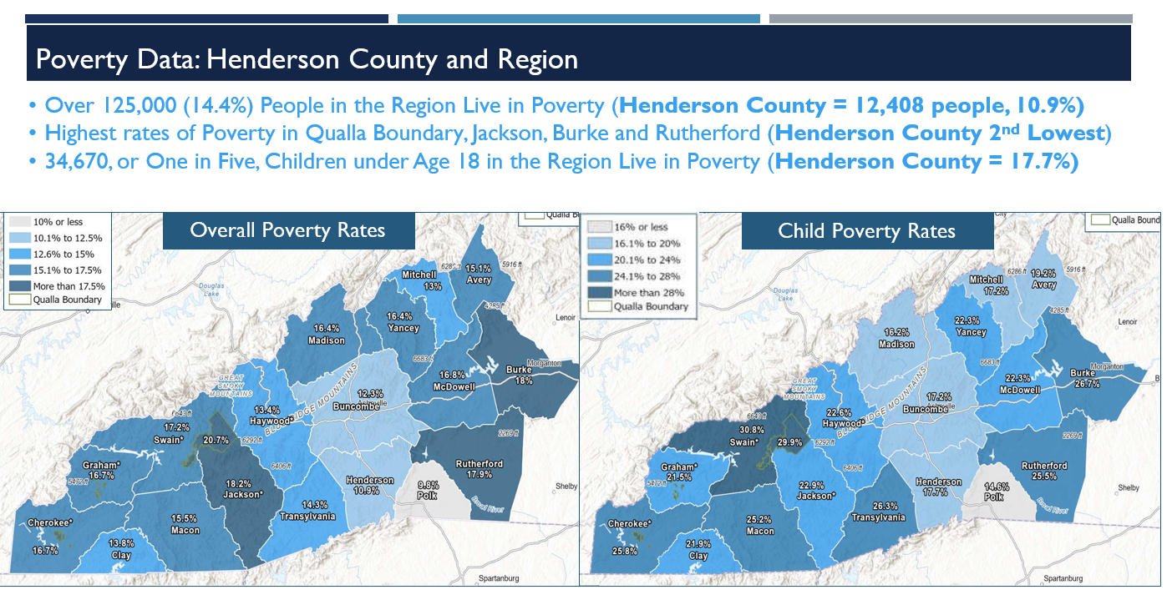
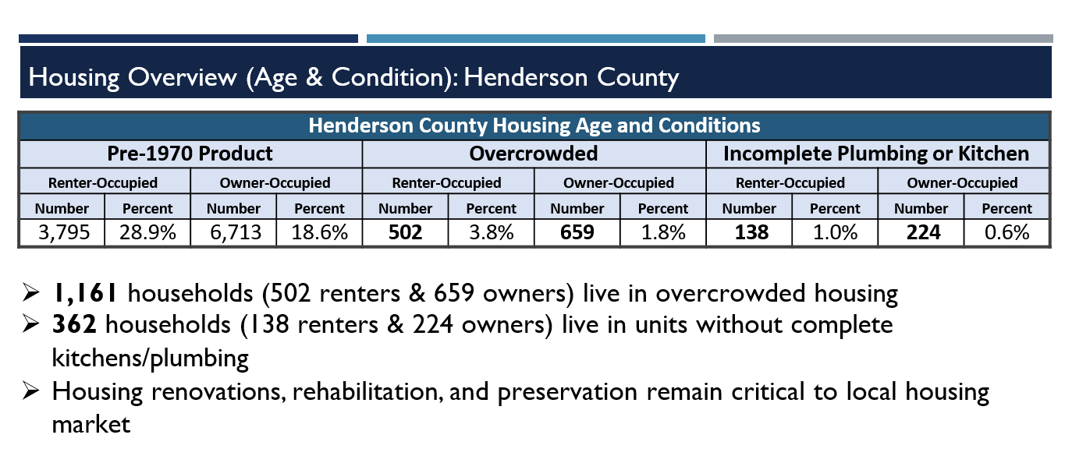
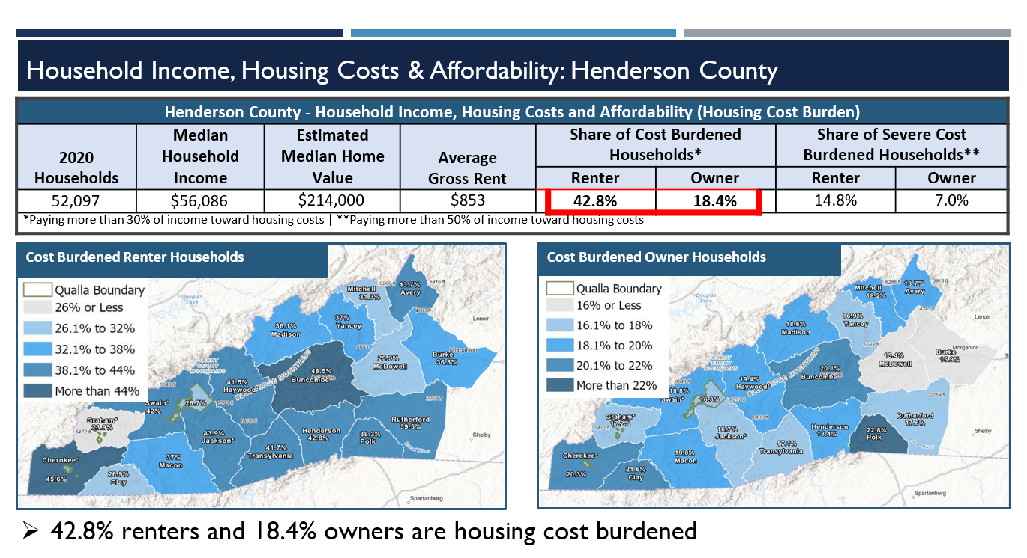
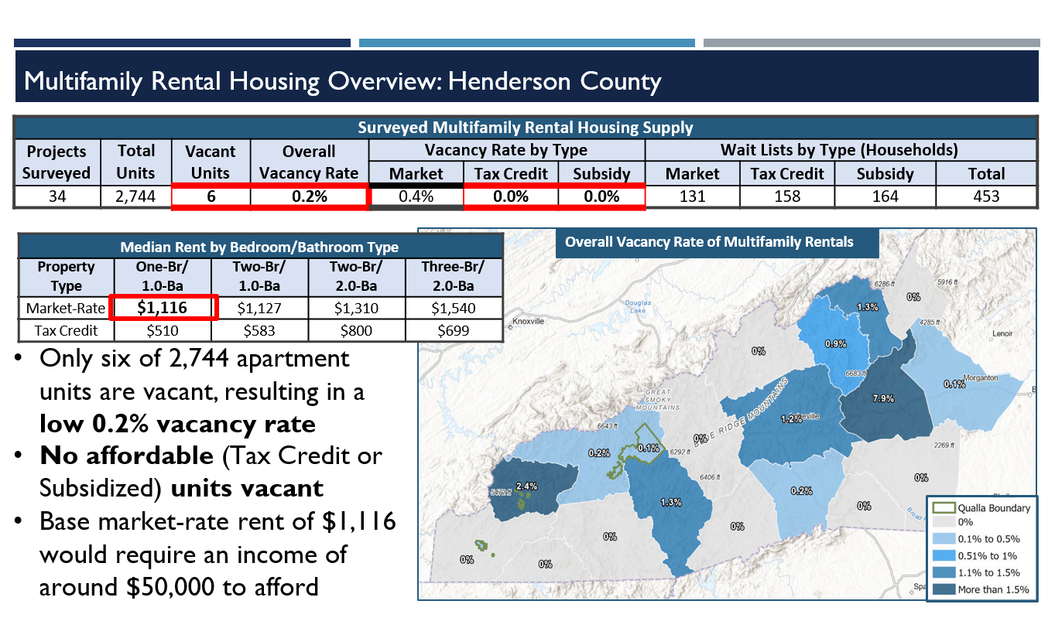
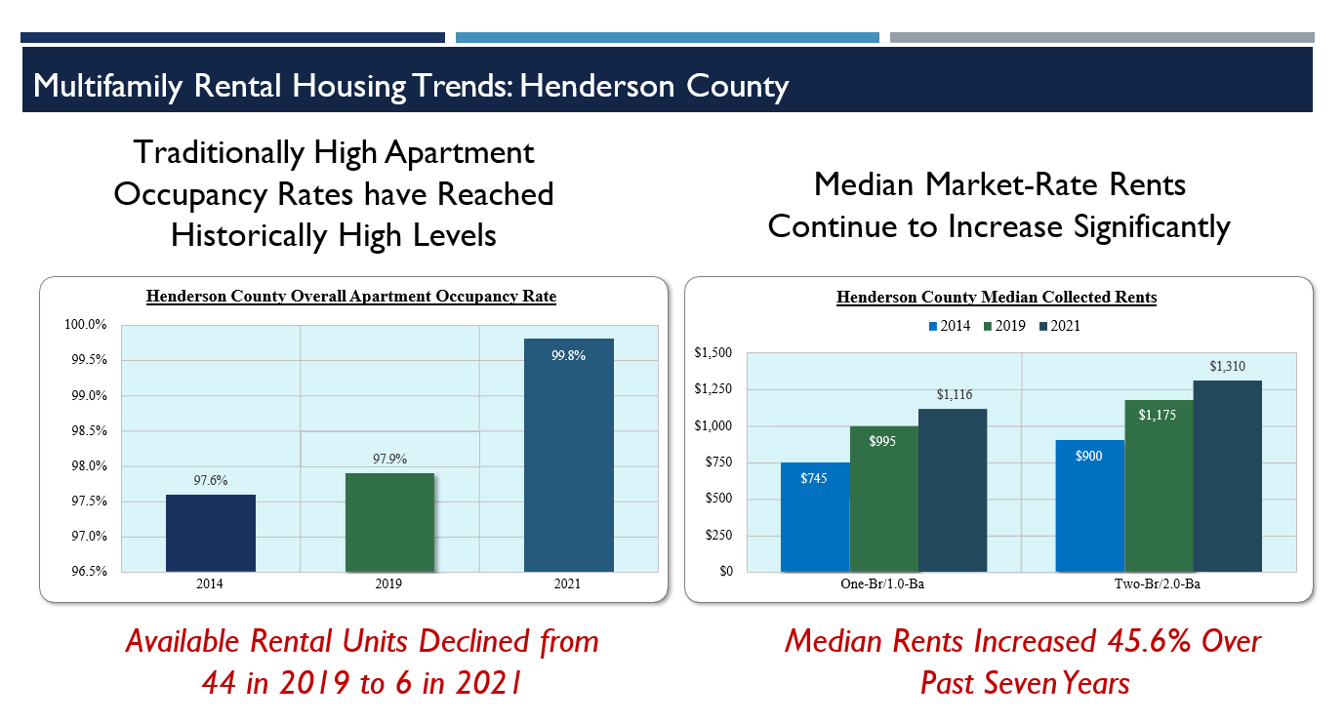
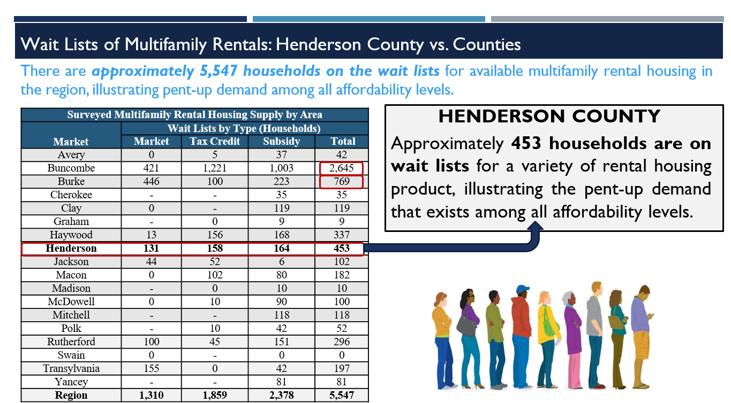
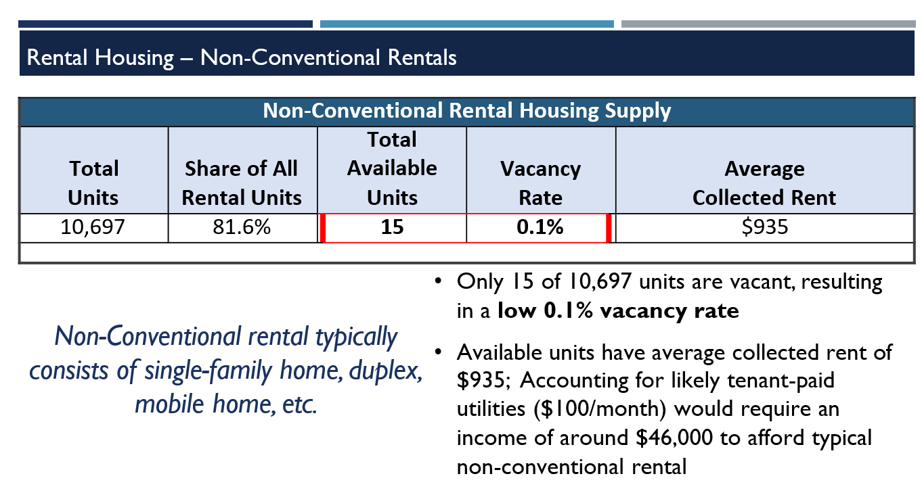

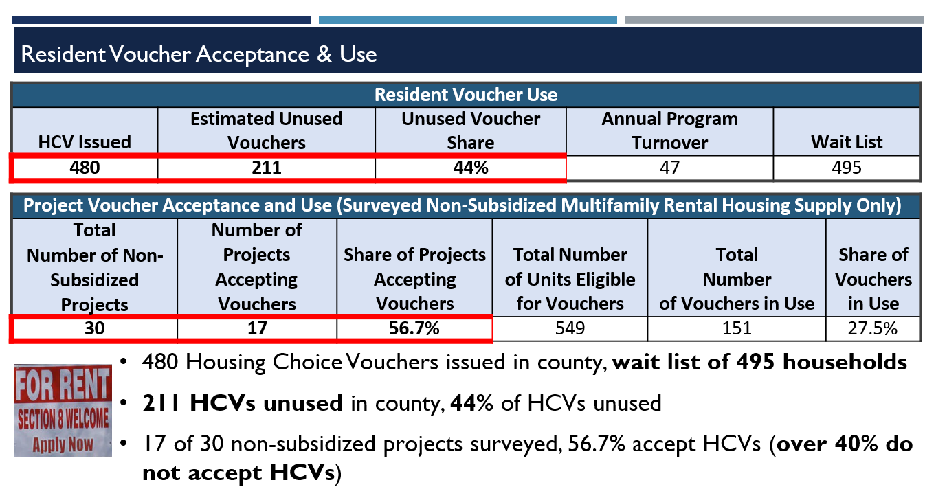
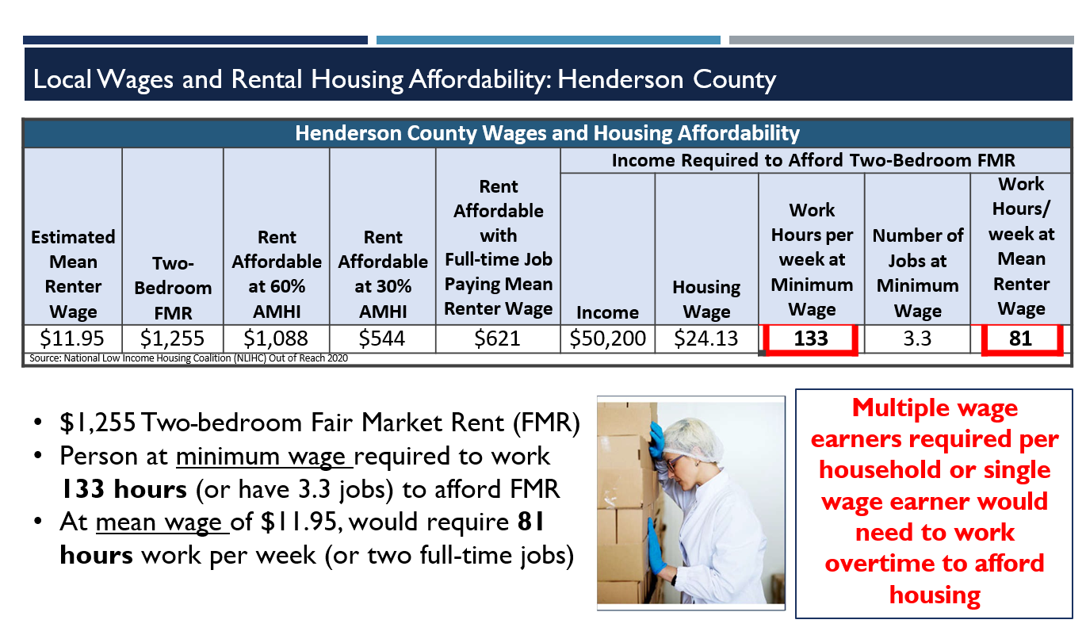
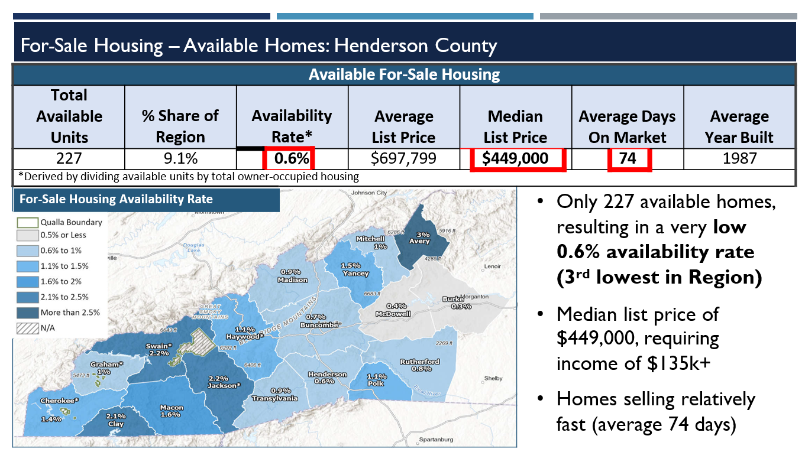
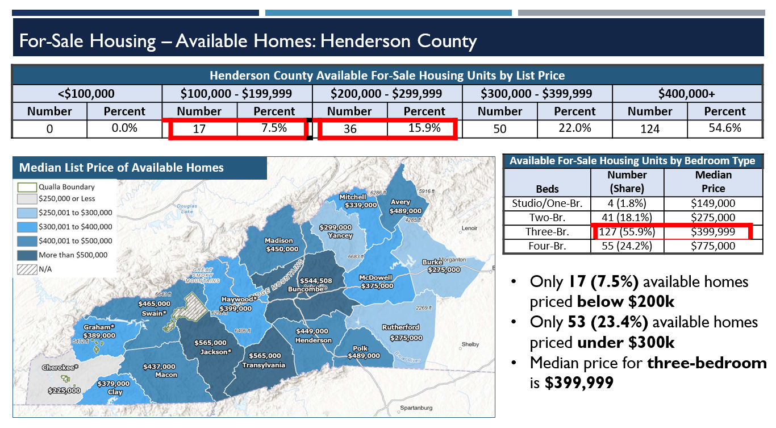
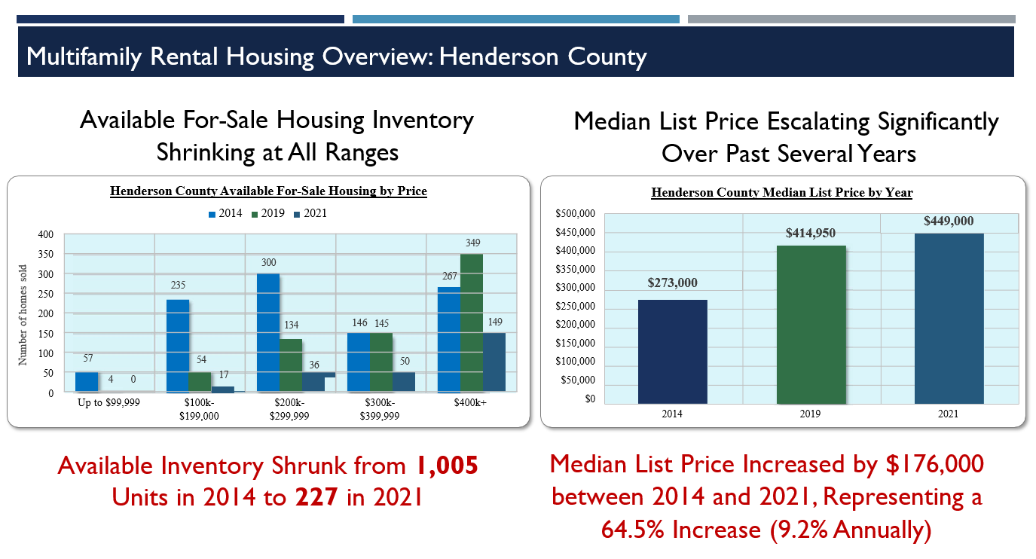
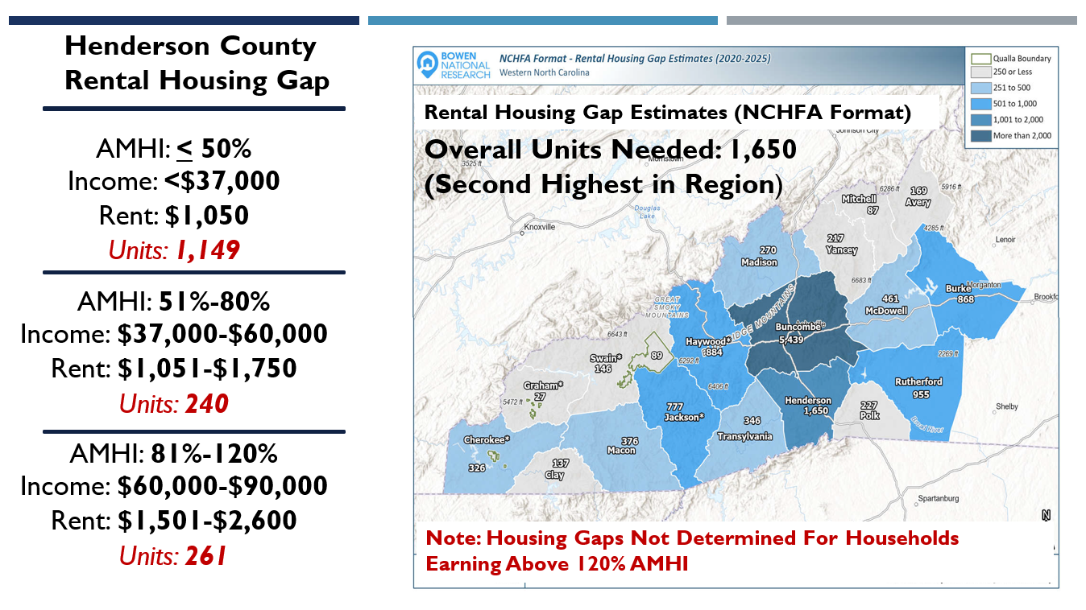

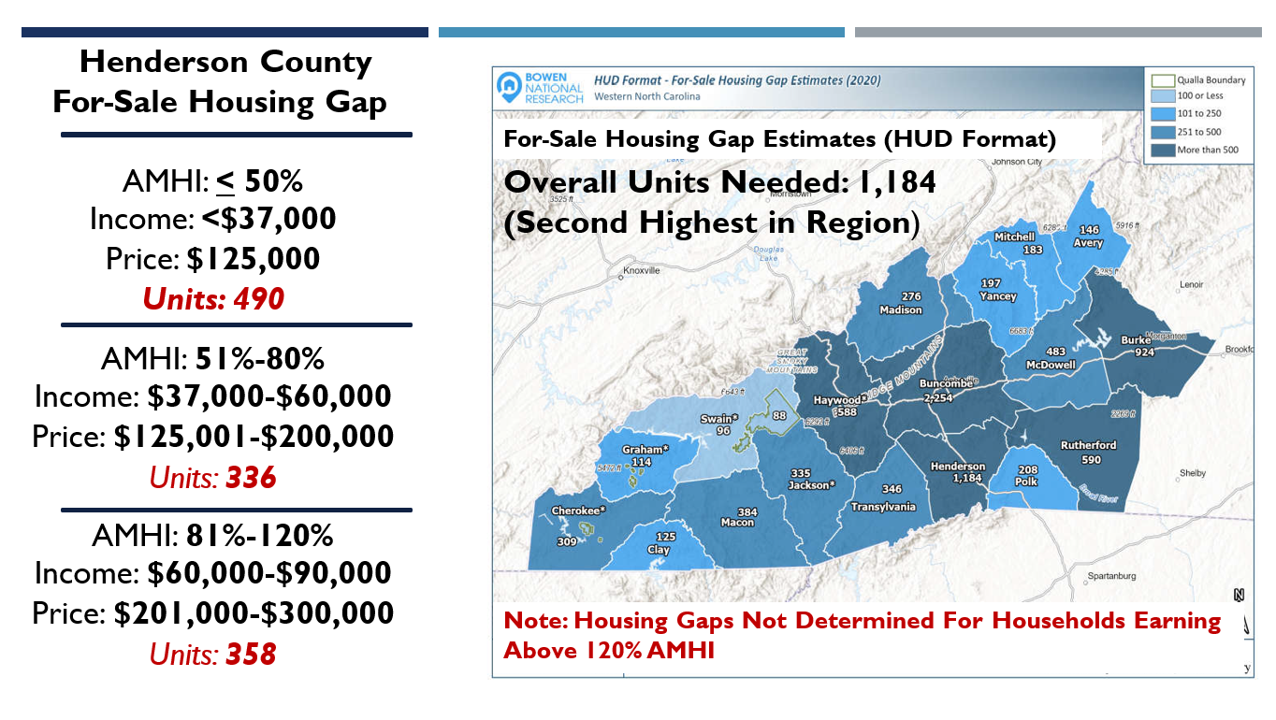
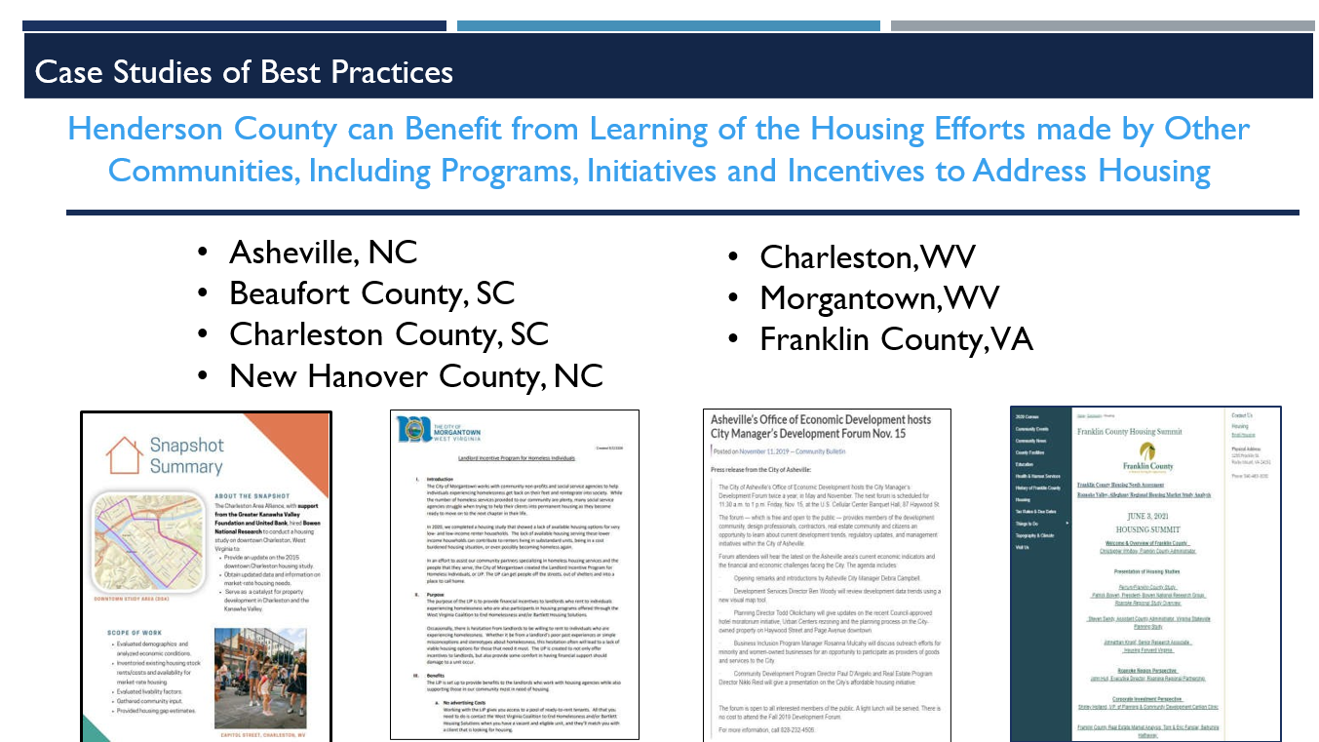

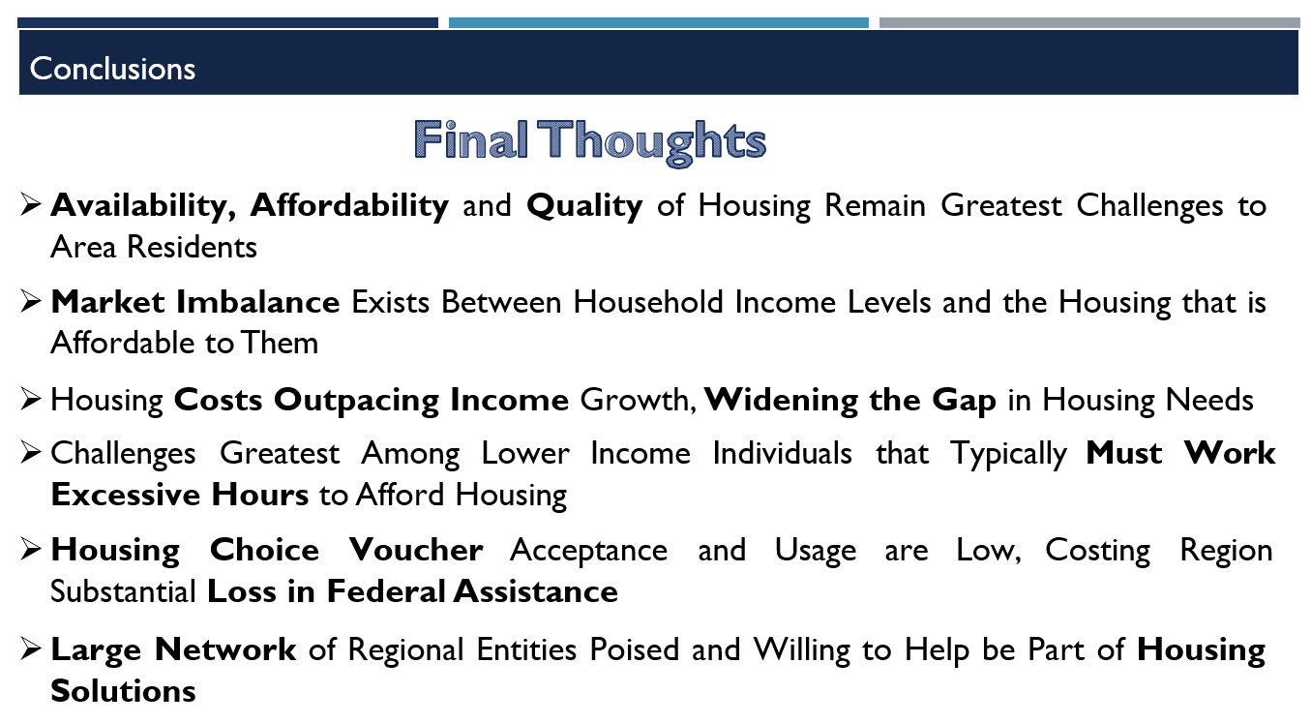
C. Creating the Affordable City – Lyndsey Simpson, Mayor Pro Tem and Angie Beeker
City Attorney Beeker said she just wanted to introduce the book “The Affordable City” as everyone should have a copy by now. It’s intended to be a guidebook or food for thought. There will be things in here that you hate and nobody is saying that all of this would work for the City of Hendersonville but it is certainly pretty comprehensive approaches and strategies. She showed the following PowerPoint presentation.

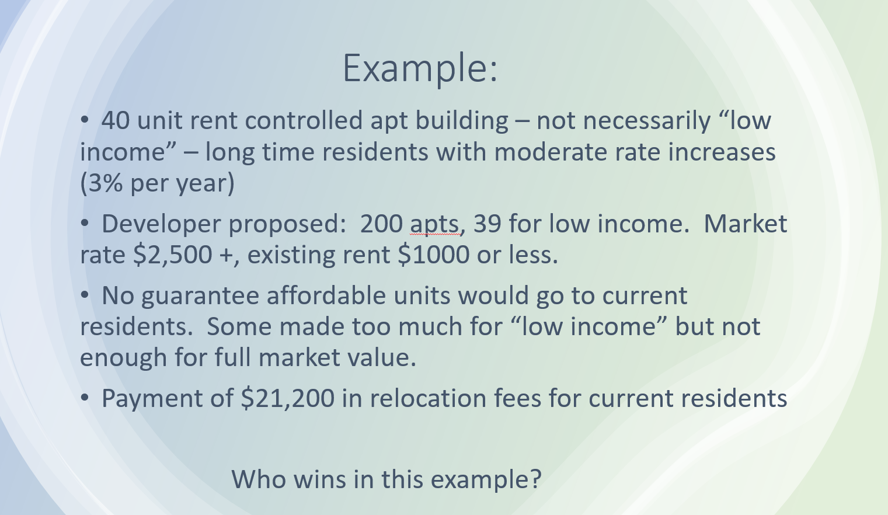

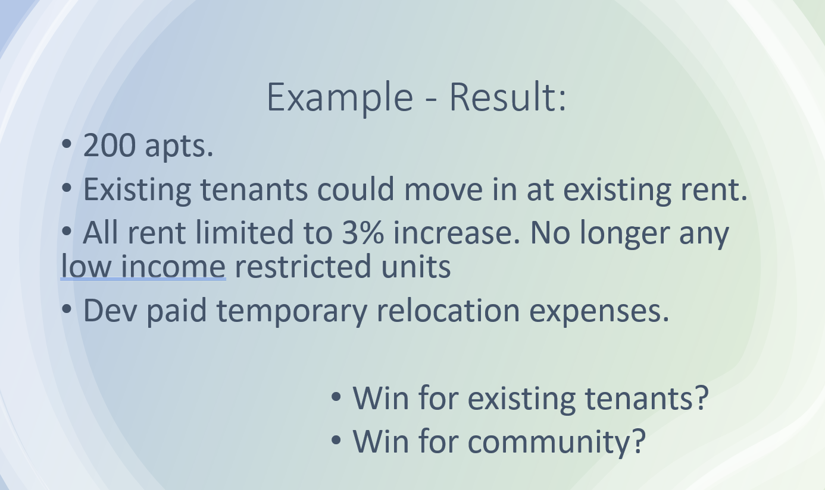
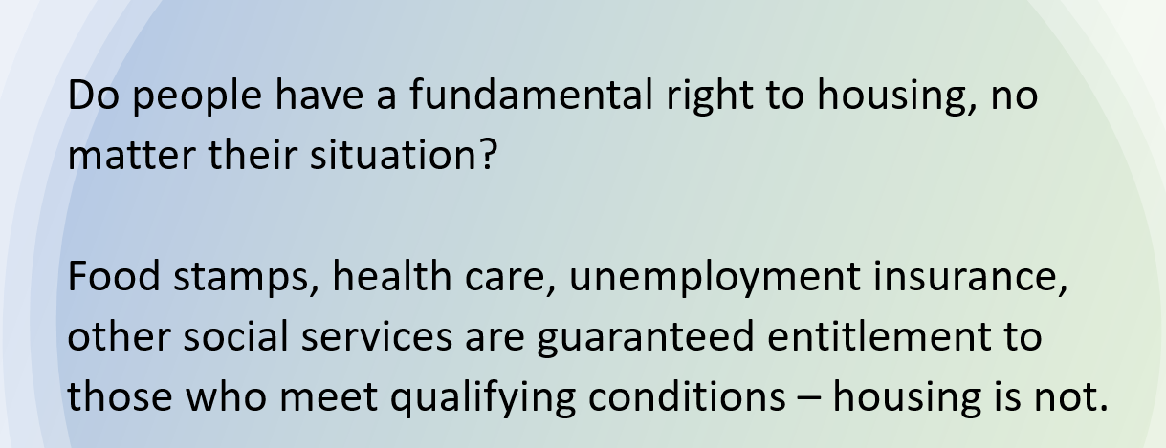
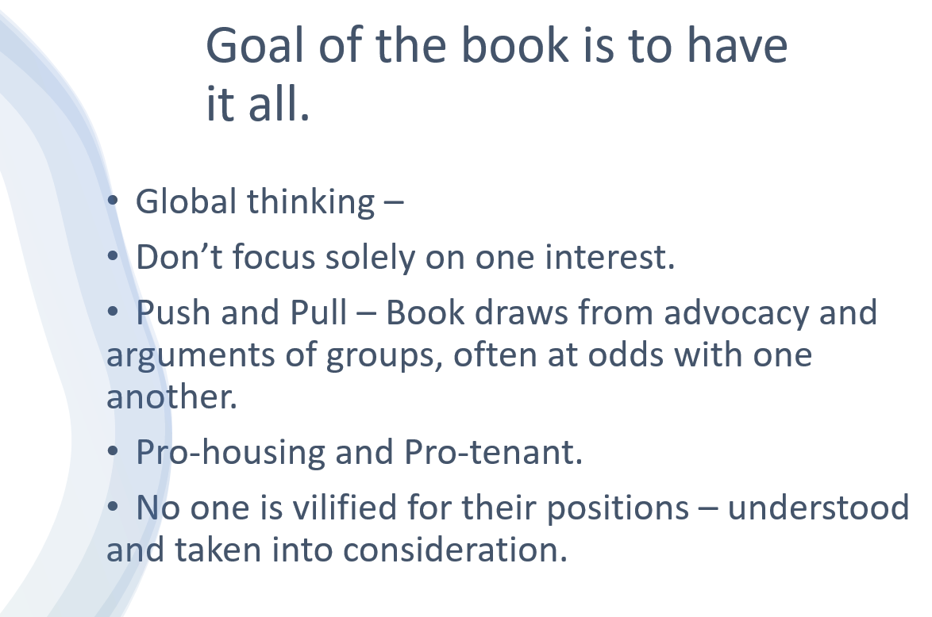

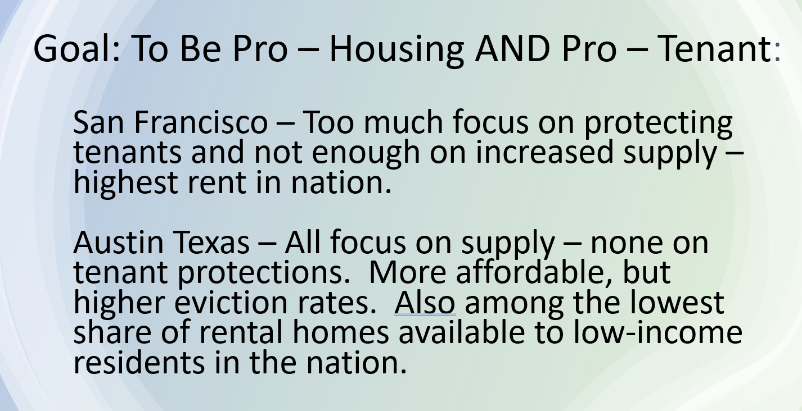

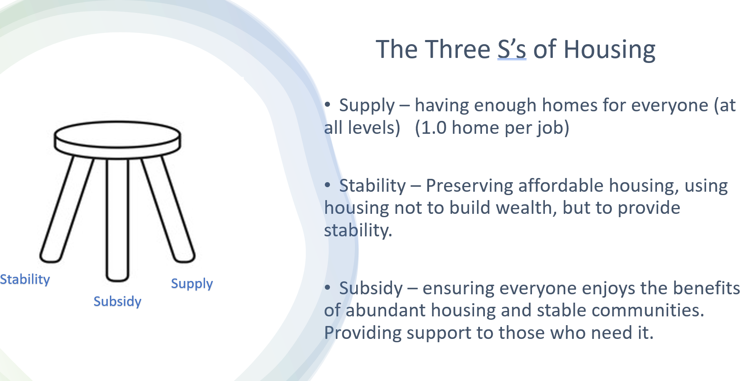

City Manager Connet added that we have a call next week with a group out of UNC Chapel Hill that works with local governments that helps work with a variety of developments, strategies, initiatives and they do a lot of work with communities around the state and they’ve created this niche for affordable housing, so we have a call with them to kind of pick their brains and tell us what they’re seeing around the state.
5. OTHER BUSINESS – None

Council Member Hensely mentioned that the next meeting is Monday, May 20th and she will be there but will have to leave early.

6. ADJOURNMENT

There being no further business, the meeting was adjourned at 5:19 p.m.

________________________________________________
Jennifer Hensley, City Council Member & Chairman
ATTEST:

_____________________________
Jill Murray, City Clerk

