 | CITY OF HENDERSONVILLE
 | STRATEGIC HOUSING PLAN STEERING COMMMITTEE
 | 2nd Floor Meeting Room | 160 6th Avenue E. | Hendersonville NC 28792
 | Monday, July 15, 2024 – 4:00 PM
Minutes
Present: Council Member Lyndsey Simpson, Council Member Jennifer Hensley, Robert Hooper (WNC Source), Debi Smith, (TDA), Sarah Cosgrove (Builder’s Assoc. of the Blue Ridge), Madeline Offen (Pisgah Legal), Connie Stewart (Housing Authority); Hilary Paradise (Land of Sky); Carsten Erkel (Partnership for Economic Development)

Absent: Jennifer Duvall (HAC),

Staff Present: City Manager John Connet, City Attorney Angela Beeker, City Clerk Jill Murray, Communications Manager Allison Justus

- CALL TO ORDER

Lyndsey Simpson called the meeting to order at 4:05 p.m. and welcomed those in attendance. Council Member Jennifer Hensley arrived at 4:11 p.m.

2. PUBLIC COMMENT - None

3. APPROVAL OF AGENDA

Sarah Cosgrove moved to approve the agenda as presented. A unanimous vote of the Committee Members present followed. Motion carried.

4. APPROVAL OF MINUTES

Robert Hooper moved to approve the minutes of June 17, 2024 as presented. A unanimous vote of the Committee Members present followed. Motion carried.

5. NEW BUSINESS

A. Presentation by Town of Chapel Hill Affordable Housing Community Connections – Sarah Vinas, Director
Ms. Beeker introduced Sarah Vinas Director of Affordable Housing Community Connections in Chapel Hill and she showed the following PowerPoint presentation regarding their affordable housing plan and key progress overview.
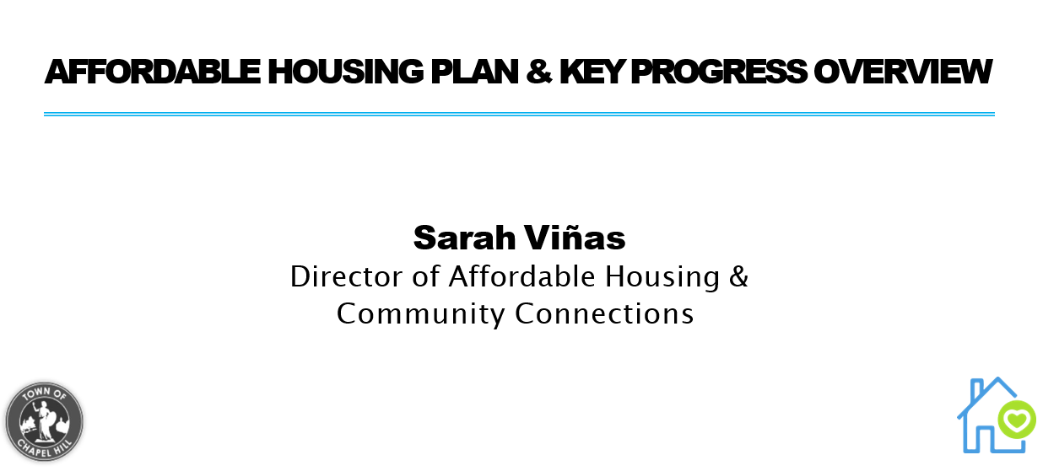

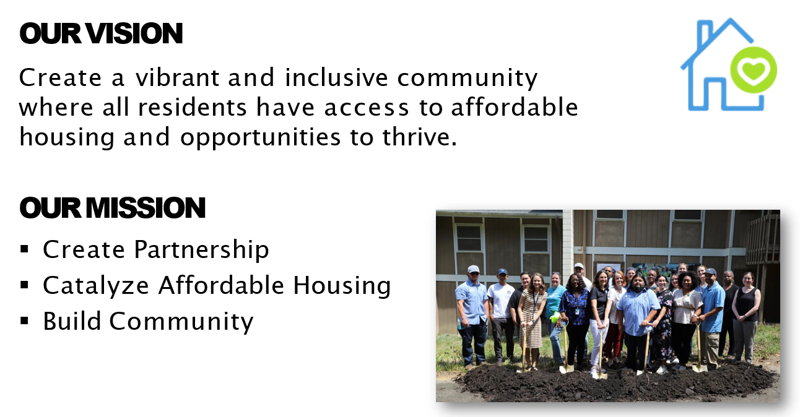

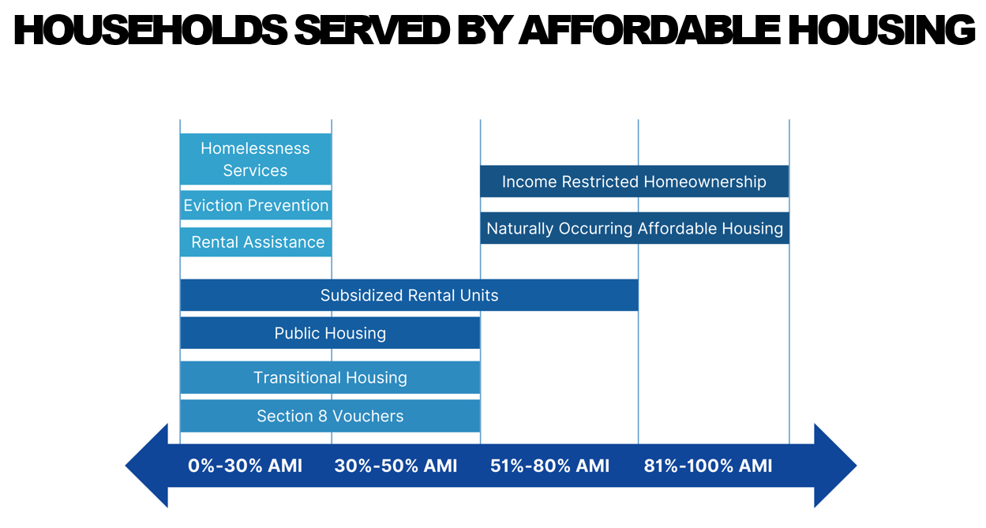
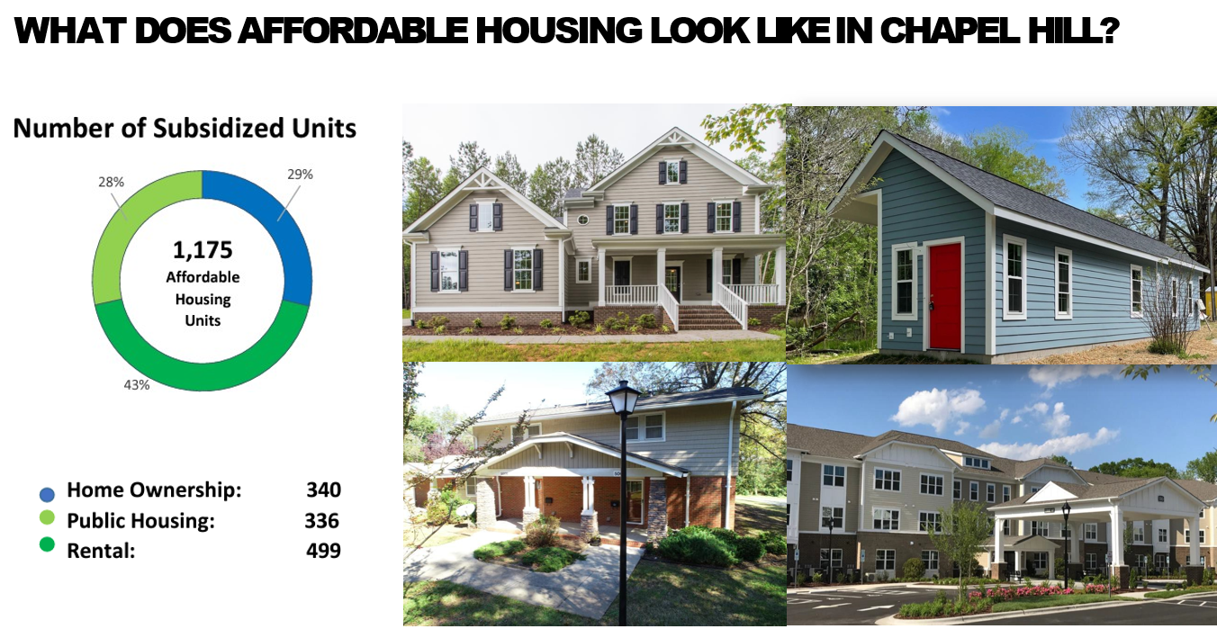

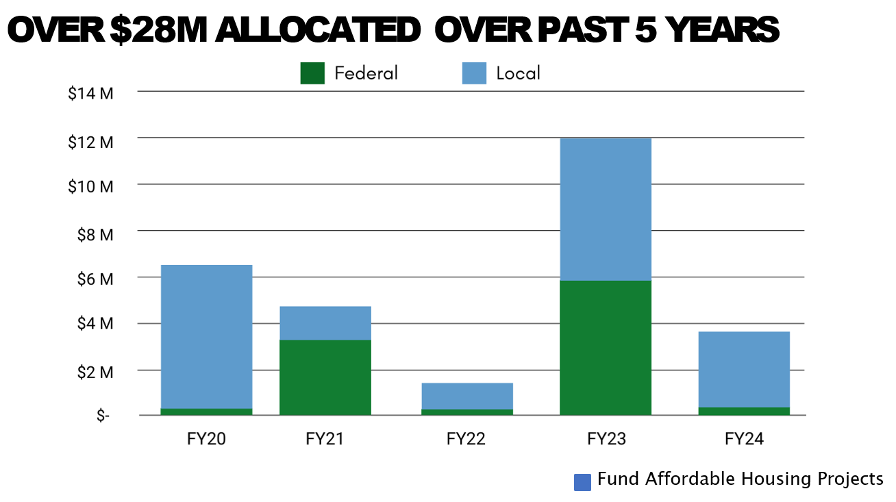
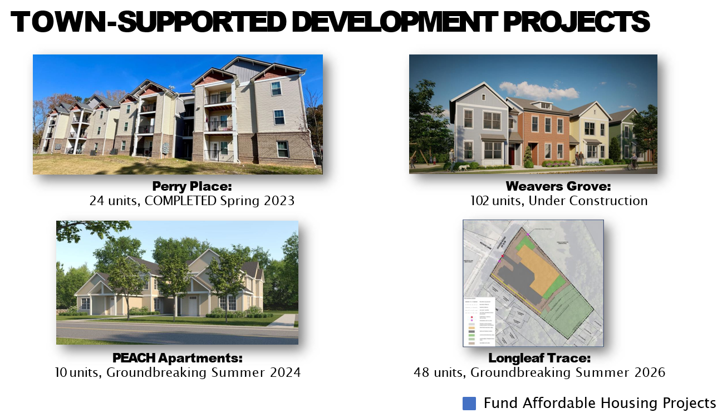
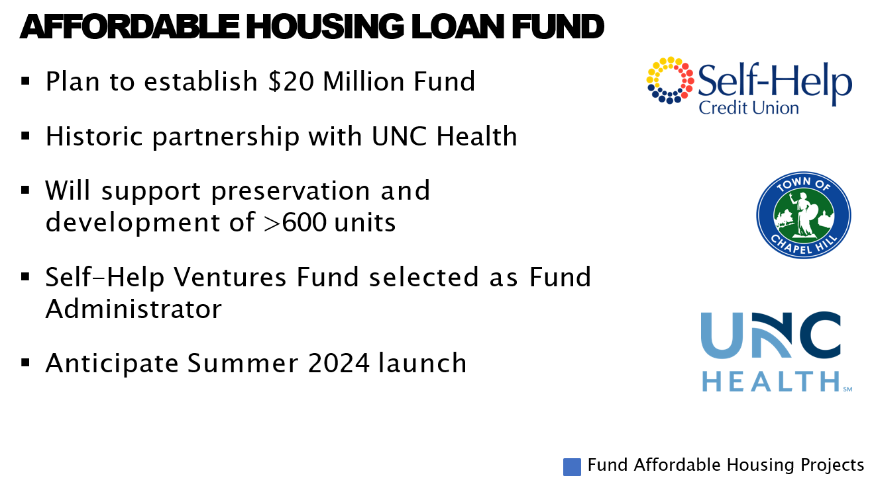
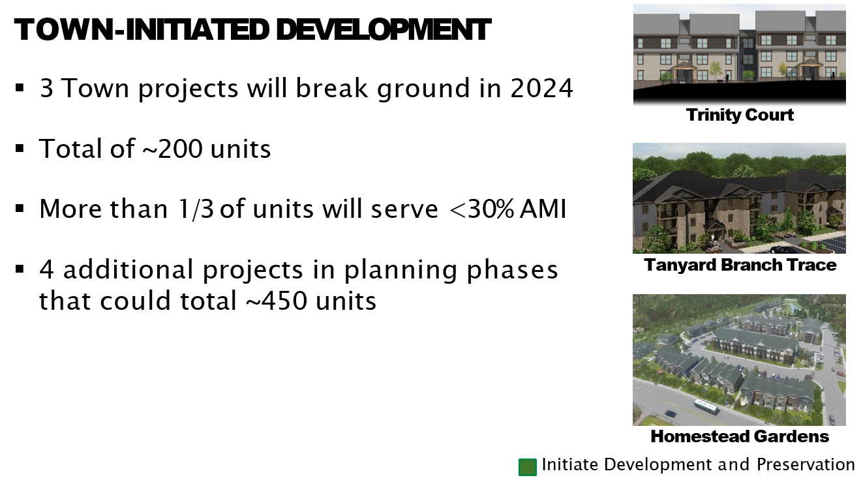
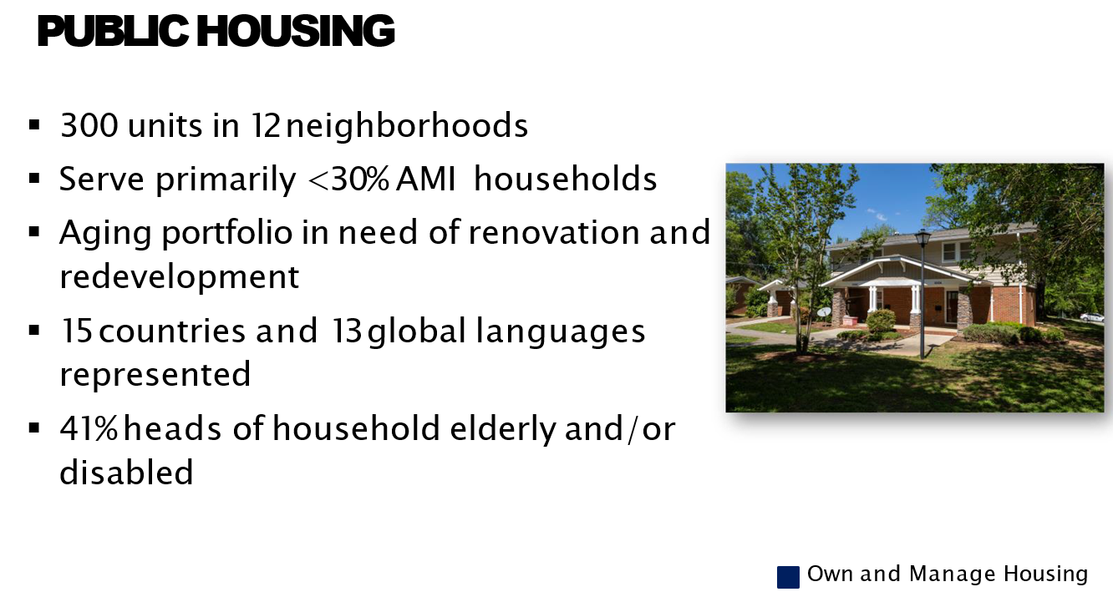

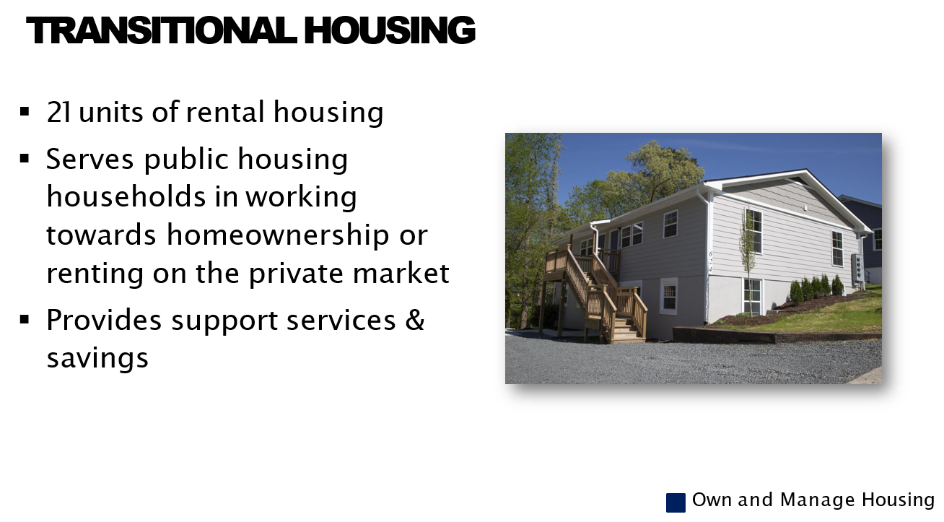
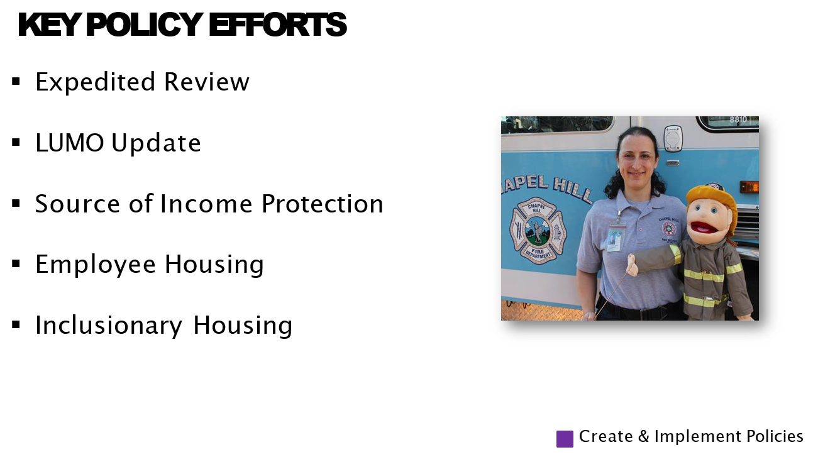

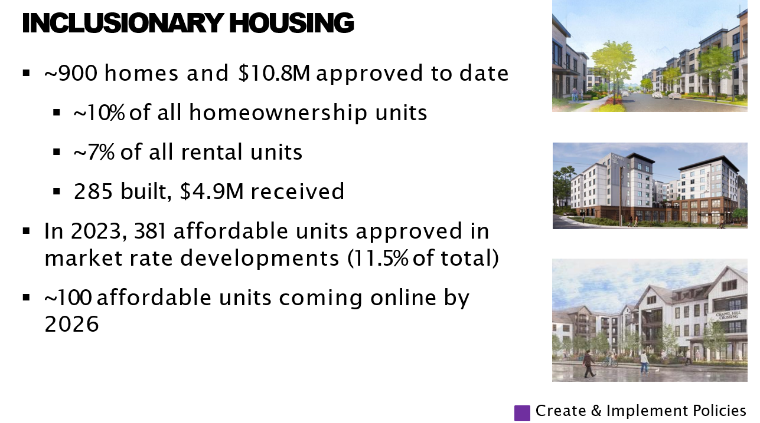

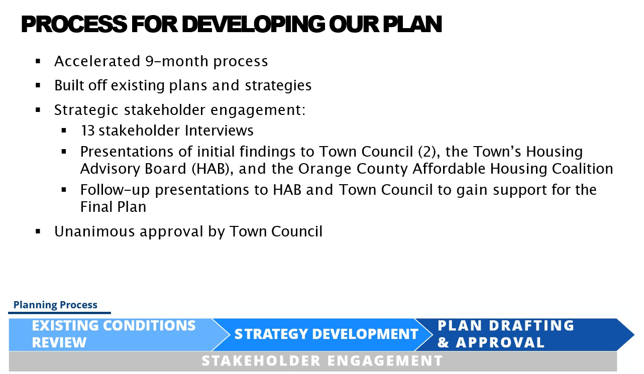
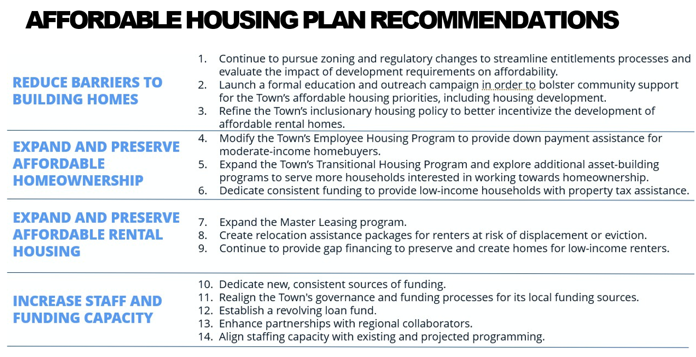
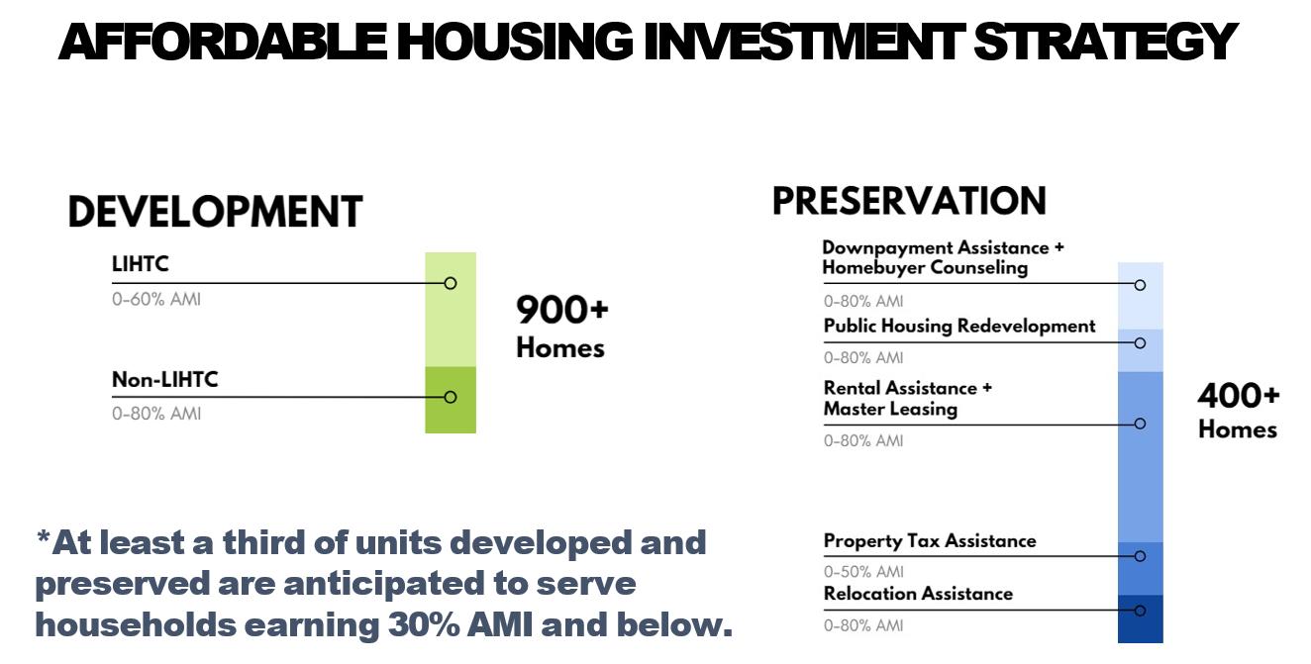
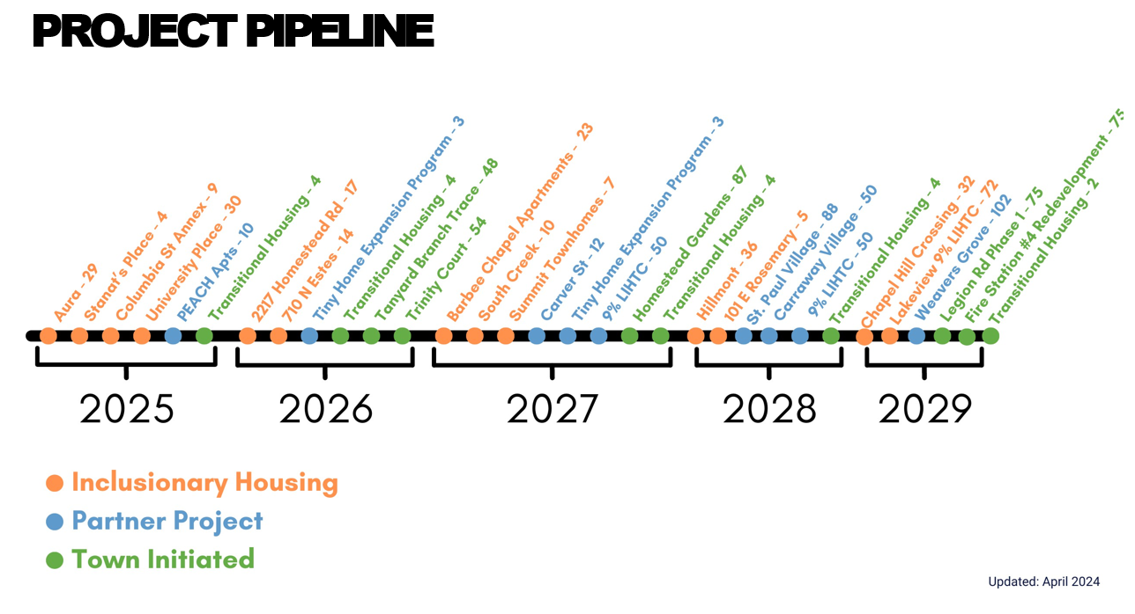
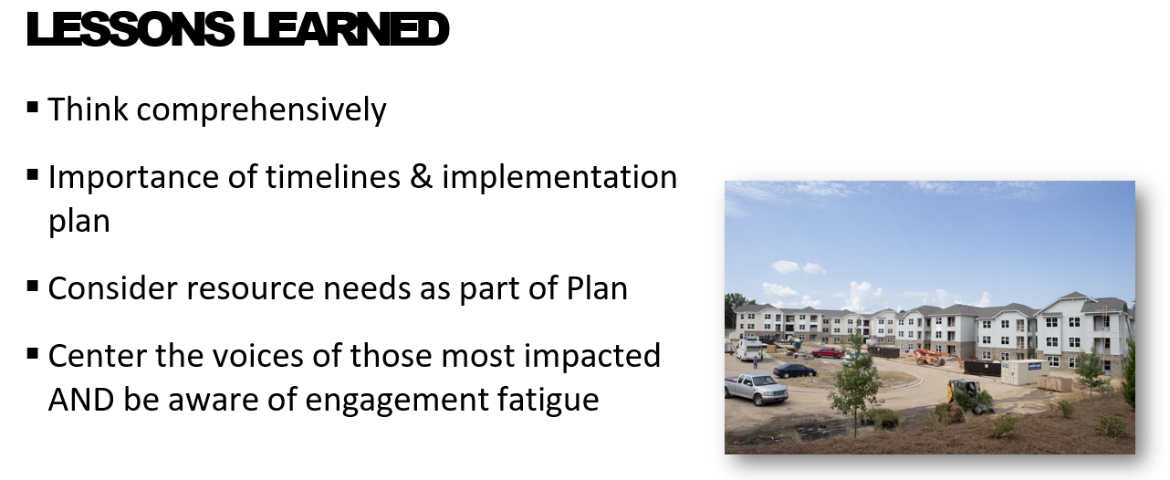
Sarah Cosgrove moved, seconded by Madeline Offen, that the city moved forward with the contract with DFI. A unanimous vote of the committee members present followed. Motion carried.
B. Discussion Regarding August 19, 2024 Meeting – Angie Beeker, City Attorney
City Attorney Angela Beeker went over the schedule for our next meeting on August 19th which will be a field trip to Chapel Hill. She mentioned letting her know if there are any dietary restrictions. She invited all of City Council, the Mayor will be there, as well as. We’ve also invited Housing Assistance Reps, Dogwood Trust and Land of Sky
Councilwoman Jennifer Hensley asked about having planners come and people from the county. Angela said that was a great idea and will look into it.
Councilwoman Lyndsey Simpson mentioned that Council approved the contract with DFI so things are moving forward.

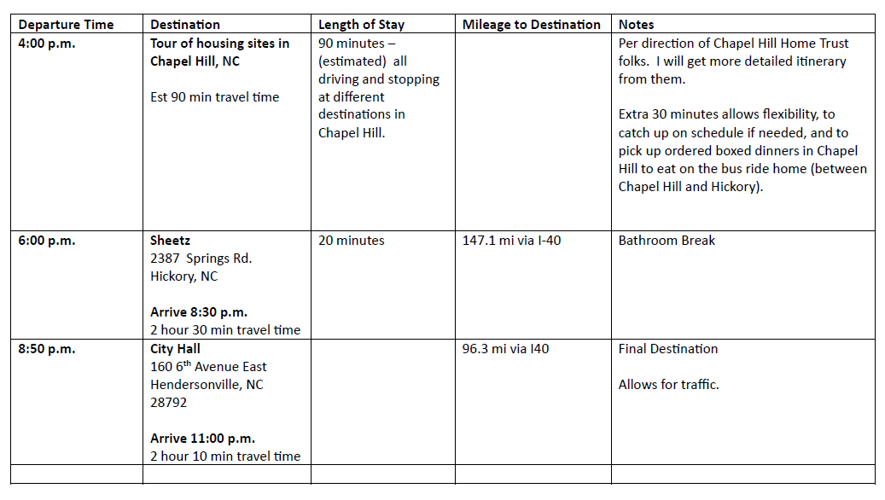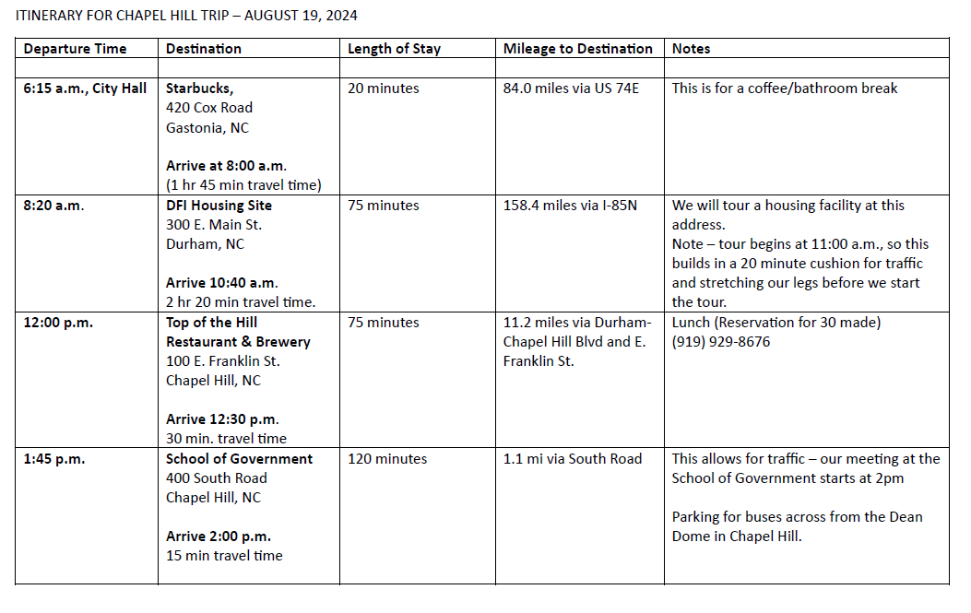

Sarah Cosgrove moved, seconded by Robert Hooper that the committee approve the plan as outlined, including the bus trip to Chapel Hill. A unanimous vote of the Committee Members present followed. Motion carried.

6. OTHER BUSINESS

Council Member Simpson said that she wanted to make sure that everyone knew that City Council approved working with DFI who we heard from and Angie told me that the contract is signed and we will be startaing that process soon.

7. ADJOURNMENT

There being no further business, the meeting was adjourned at 4:56 p.m.

________________________________________________
Lyndsey Simpson, City Council Member & Chairman
ATTEST:

_____________________________
Jill Murray, City Clerk

