 | CITY OF HENDERSONVILLE
 | STRATEGIC HOUSING PLAN STEERING COMMMITTEE
 | 2nd Floor Meeting Room | 160 6th Avenue E. | Hendersonville NC 28792
 | Monday, June 17, 2024 – 4:00 PM
Minutes
Present: Council Member Lyndsey Simpson, Council Member Jennifer Hensley, Robert Hooper (WNC Source), Debi Smith, (TDA), Jennifer Duvall (HAC), Sarah Cosgrove (Builder’s Assoc. of the Blue Ridge), Madeline Offen (Pisgah Legal), and Connie Stewart (Housing Authority)

Absent: Hilary Paradise (Land of Sky)

Staff Present: City Manager John Connet, City Attorney Angela Beeker, City Clerk Jill Murray, Communications Manager Allison Justus

- CALL TO ORDER

Jennifer Hensley called the meeting to order at 4:06 p.m. and welcomed those in attendance.

2. PUBLIC COMMENT - None

3. APPROVAL OF AGENDA

Sarah Cosgrove moved, seconded by Robert Hooper, to approve the agenda as presented. A unanimous vote of the Committee Members present followed. Motion carried.

4. APPROVAL OF MINUTES

Jennifer Duvall moved, seconded by Madeline Offen, to approve the minutes of May 20, 2024, as presented. A unanimous vote of the Committee Members present followed. Motion carried.

5. NEW BUSINESS

A. Presentation by UNC School of Government Development Finance Initiative – Angie Beeker, City Attorney & DFI Staff
Ms. Beeker introduced Marcia Perritt Director of the UNC School of Government Development Finance Initiative and she showed the following PowerPoint presentation. DFI has also submitted a proposal for service and Ms. Beeker is asking for them to vote on whether we should move forward with DFI.

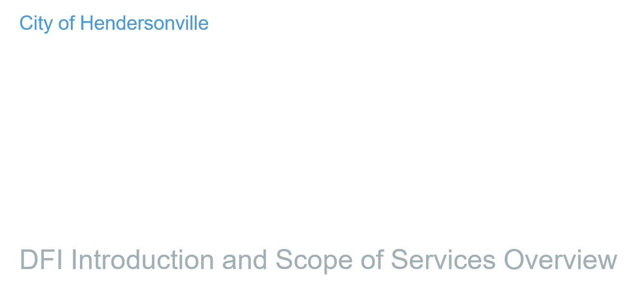
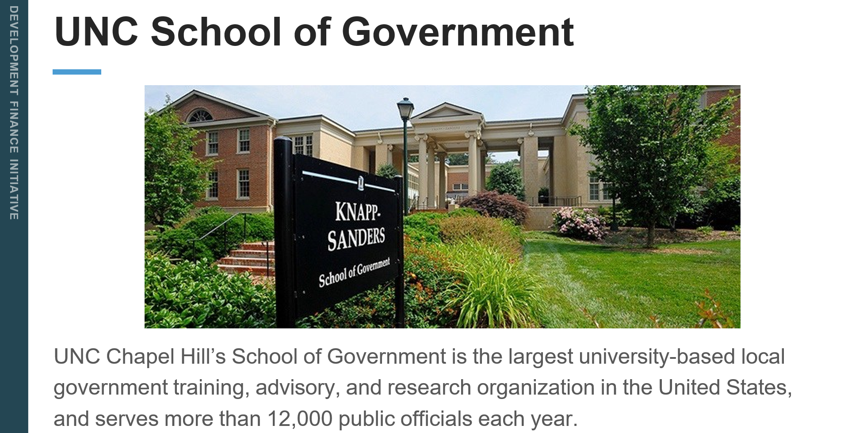
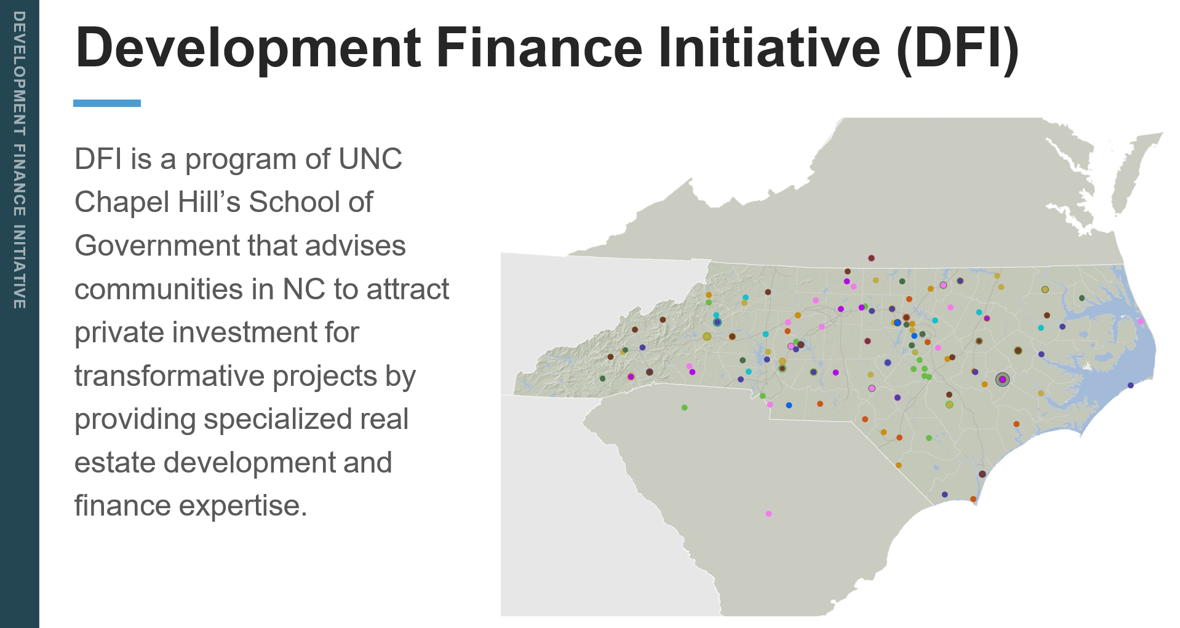
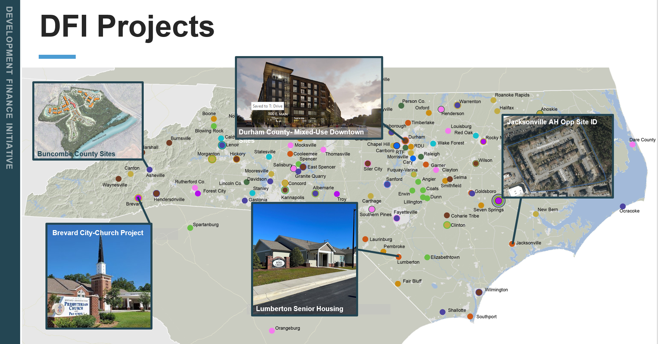

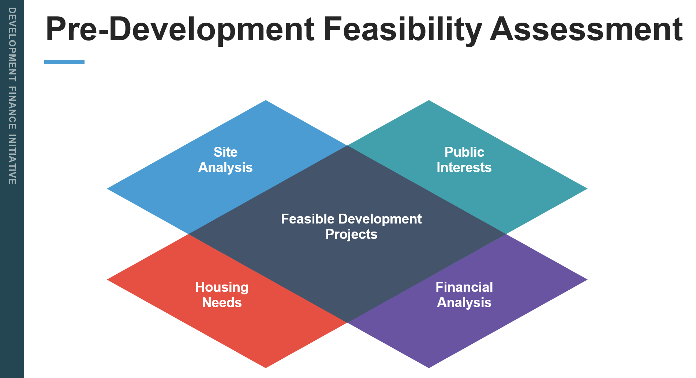
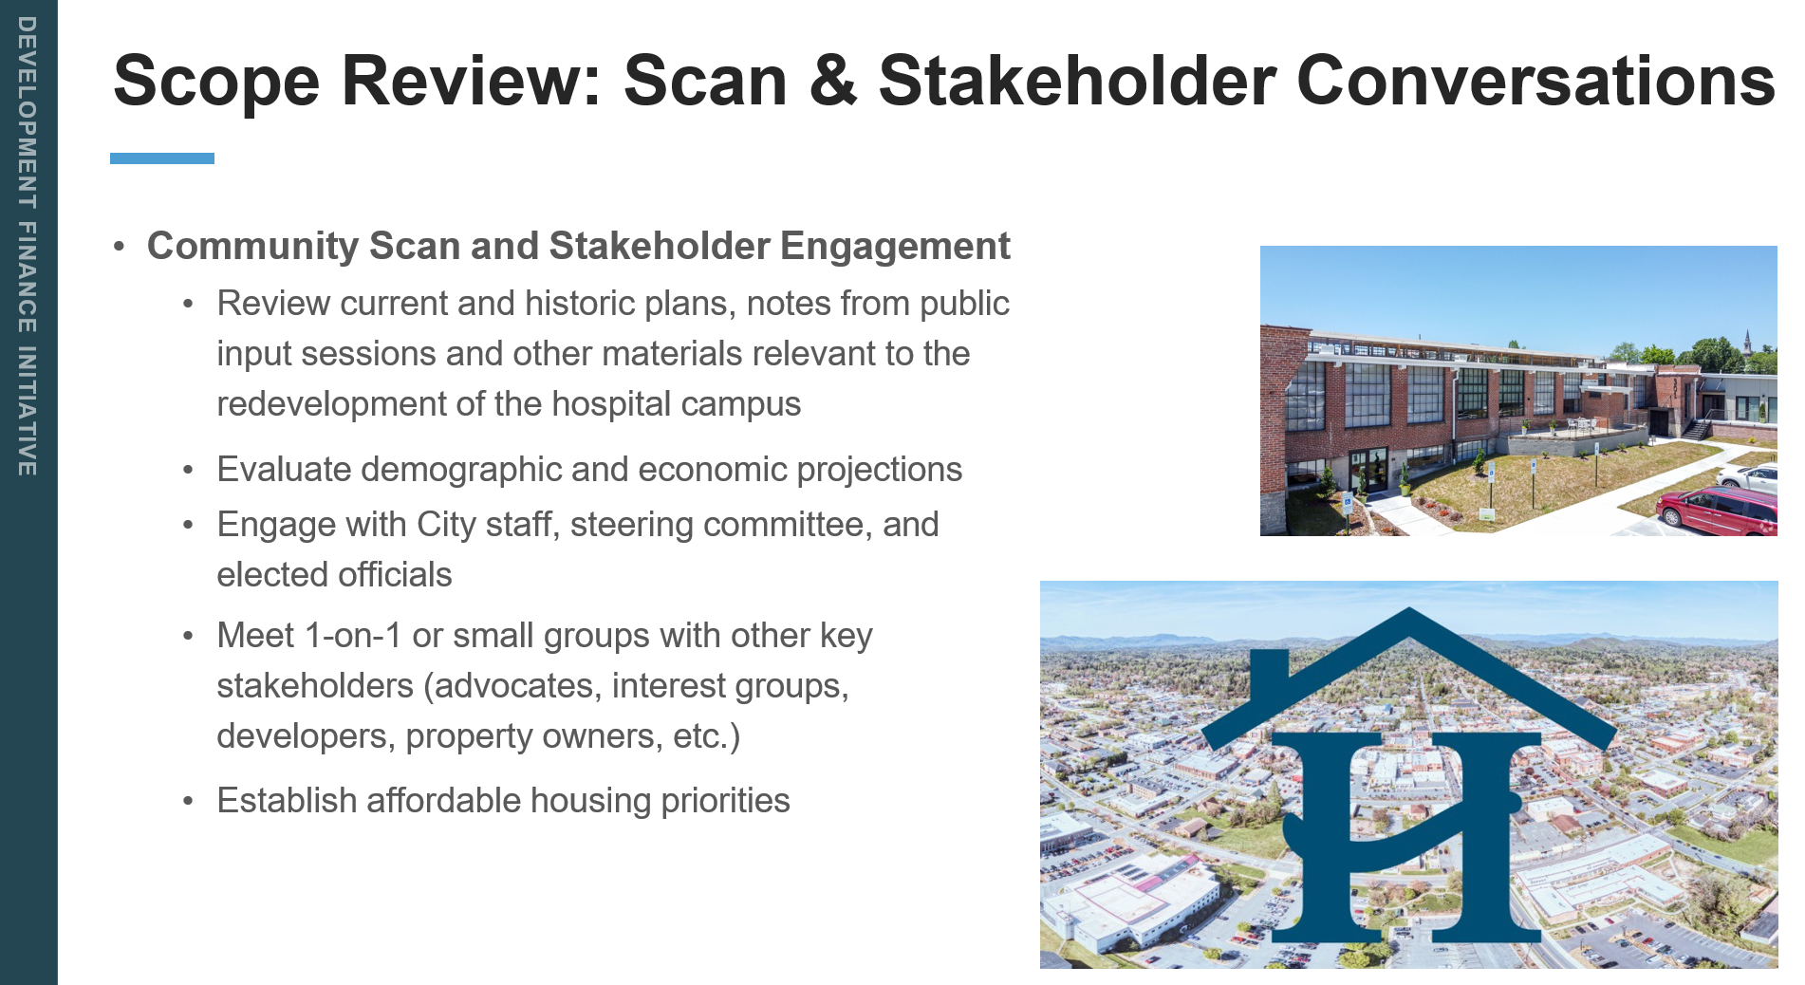
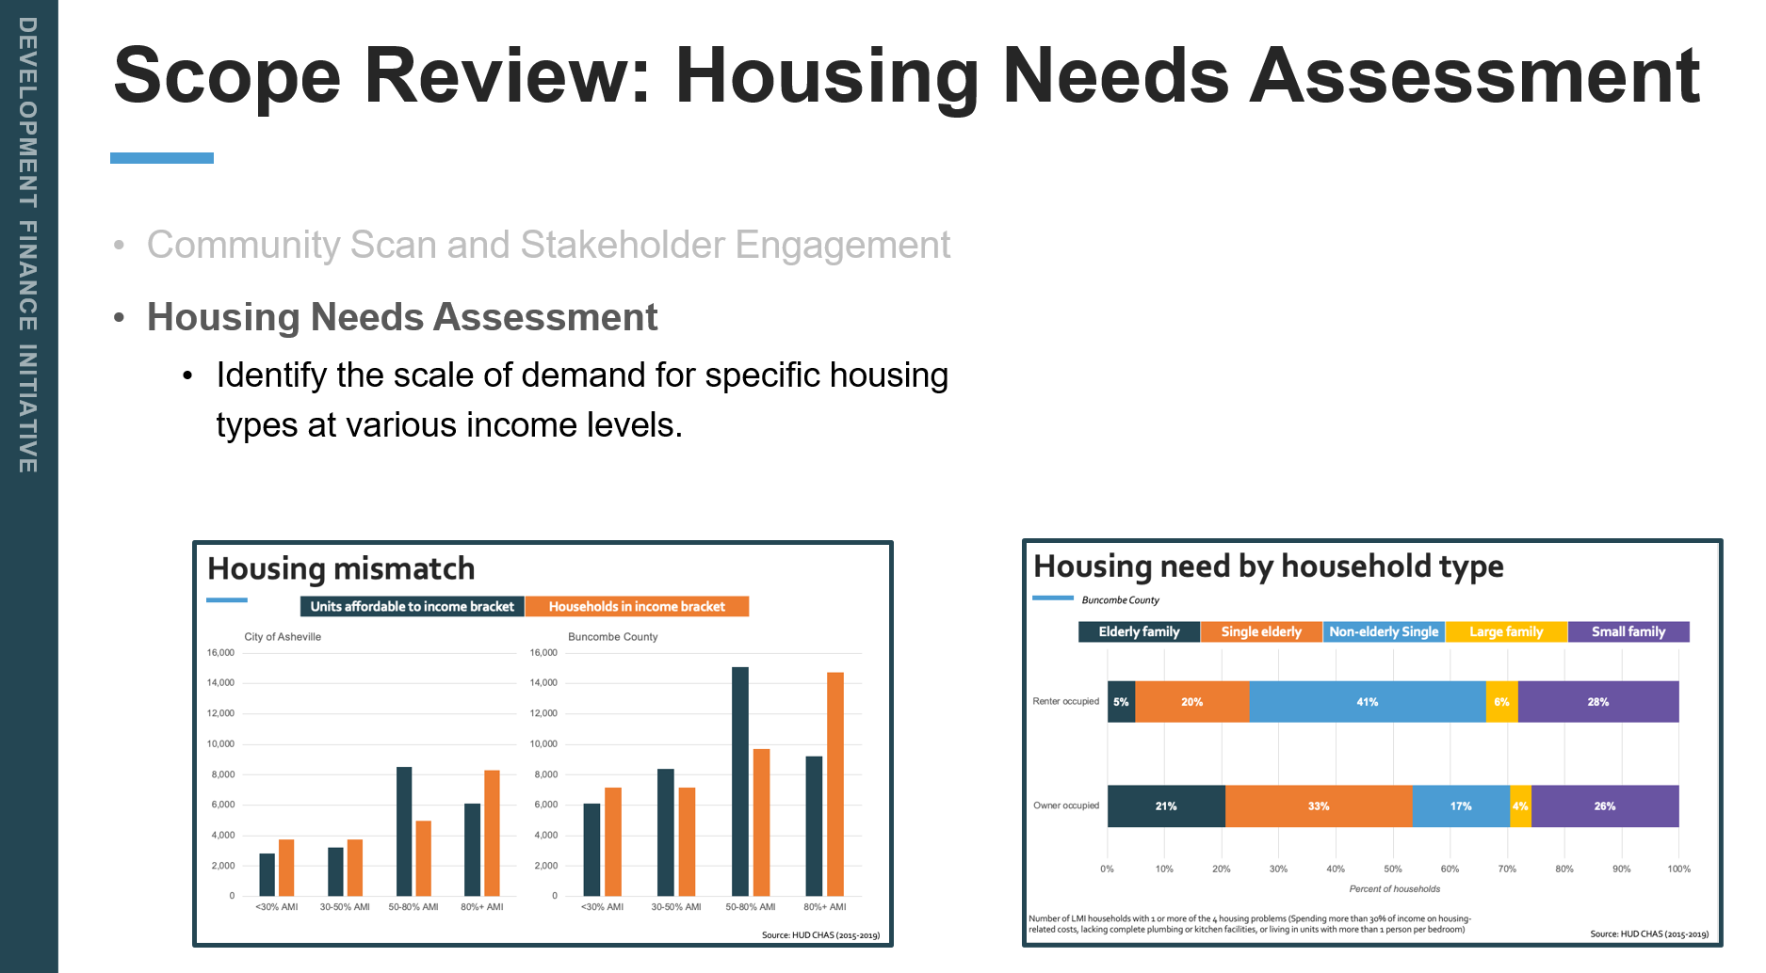
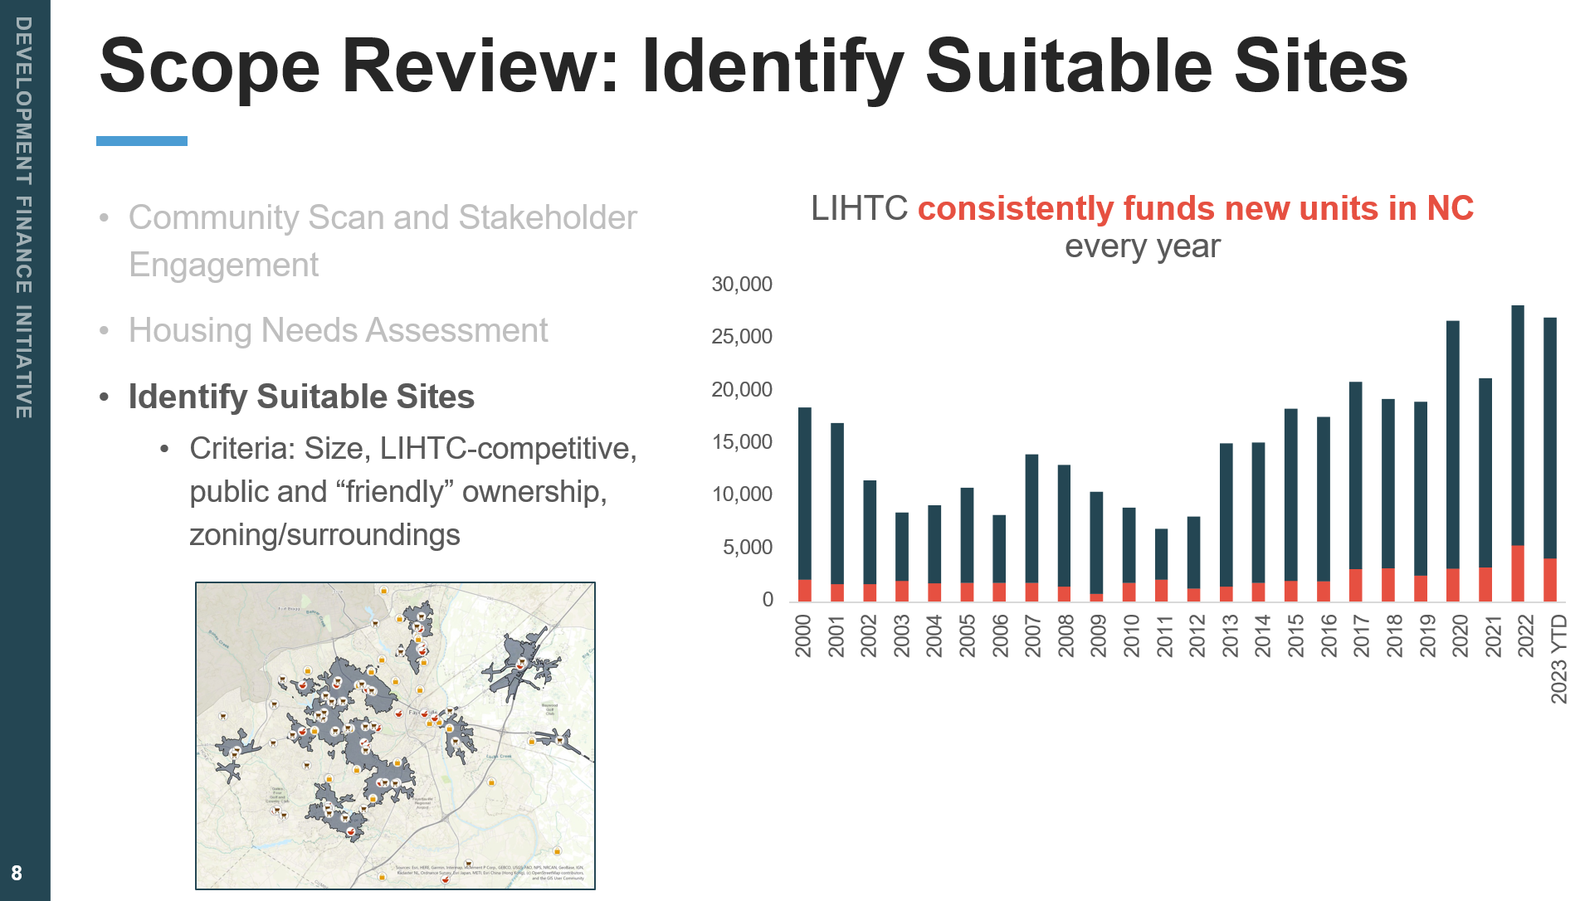
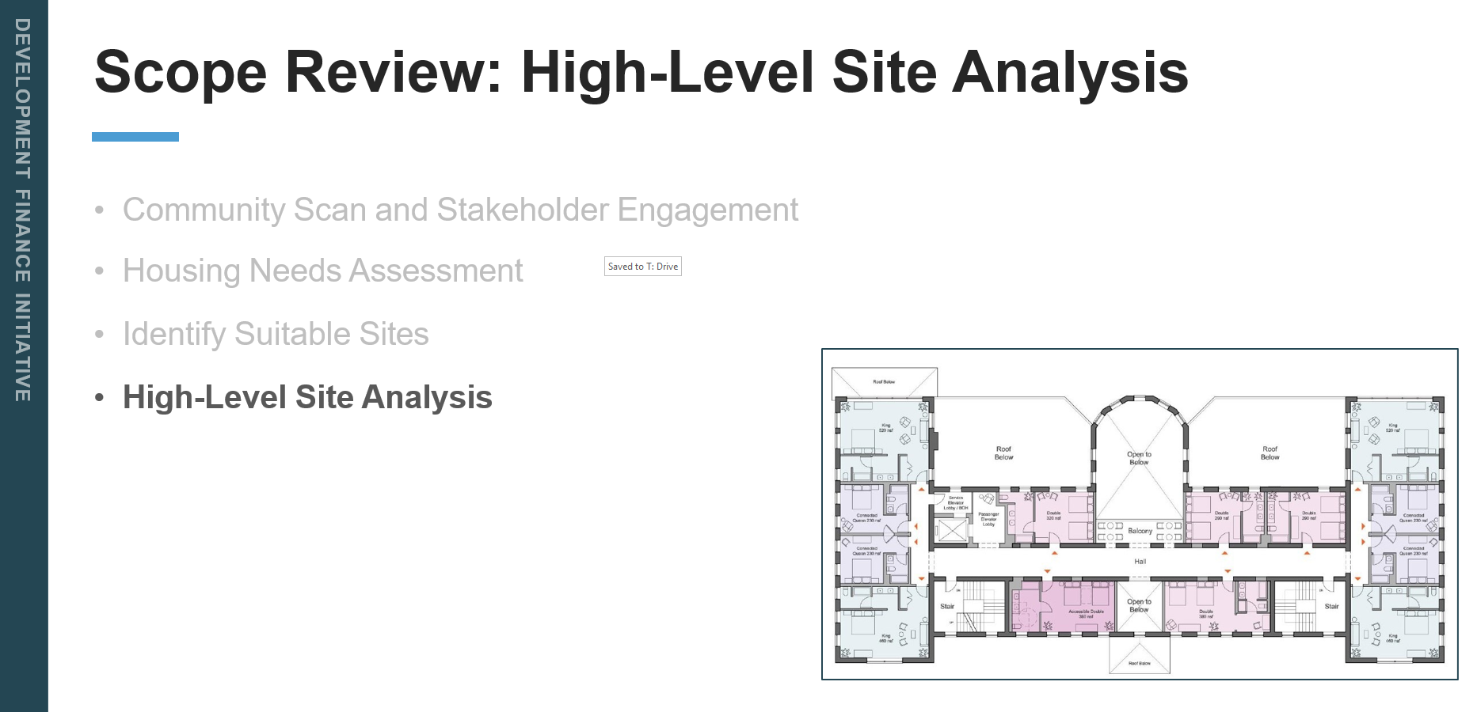

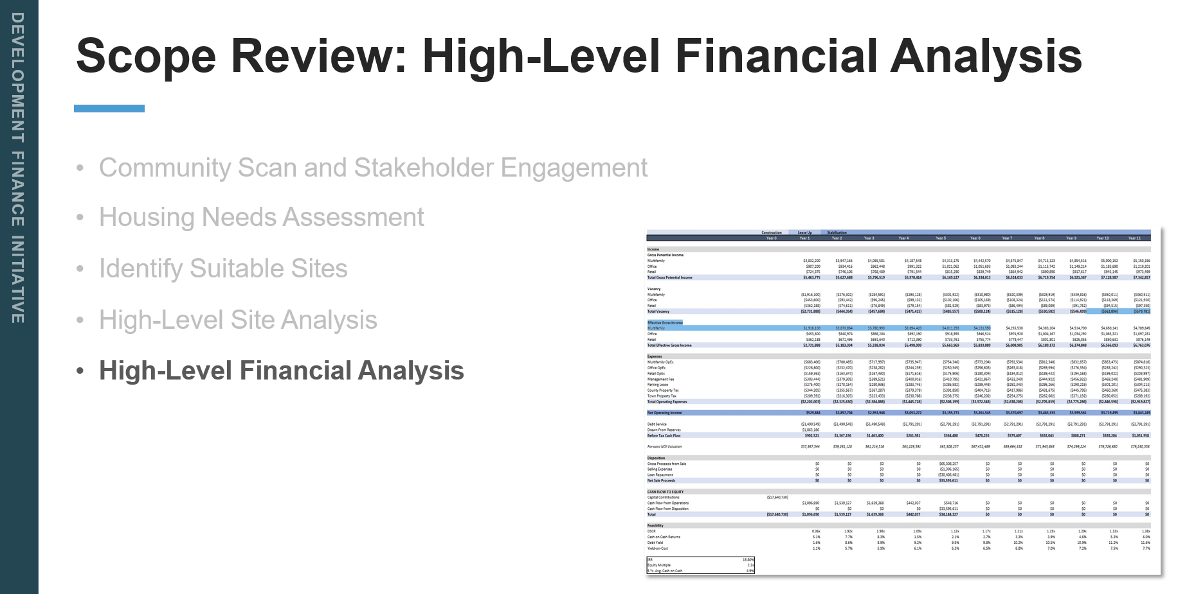
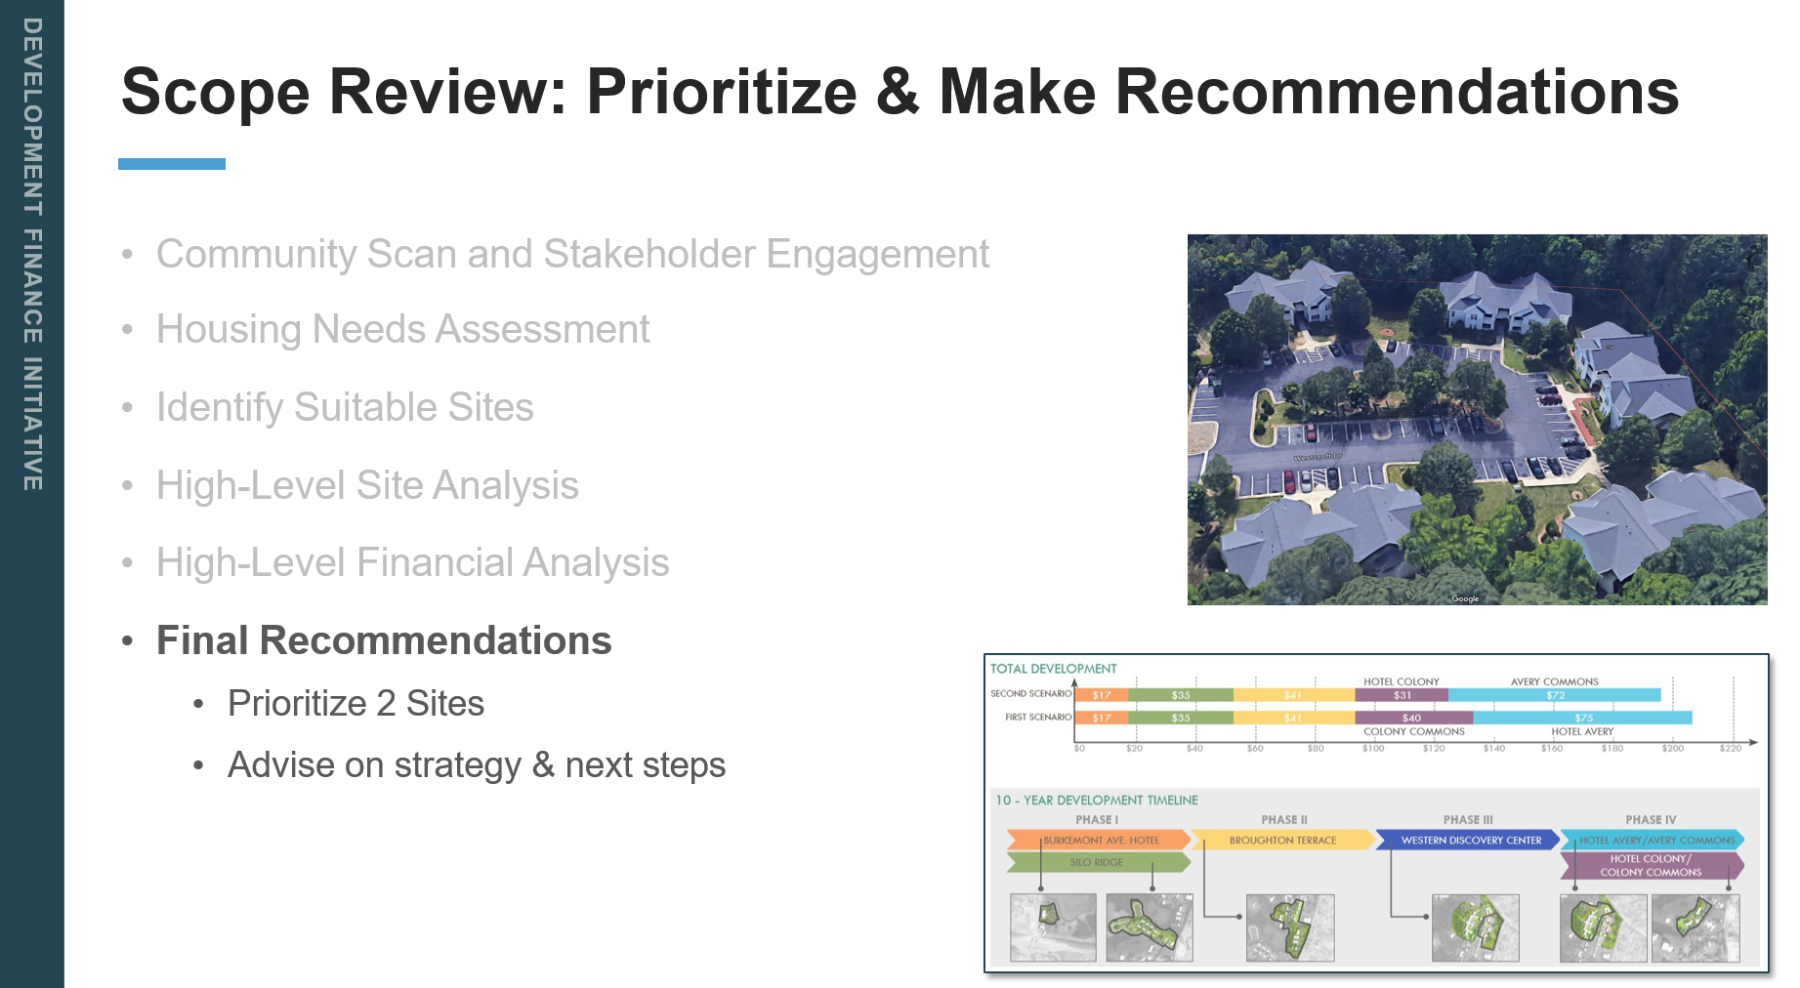
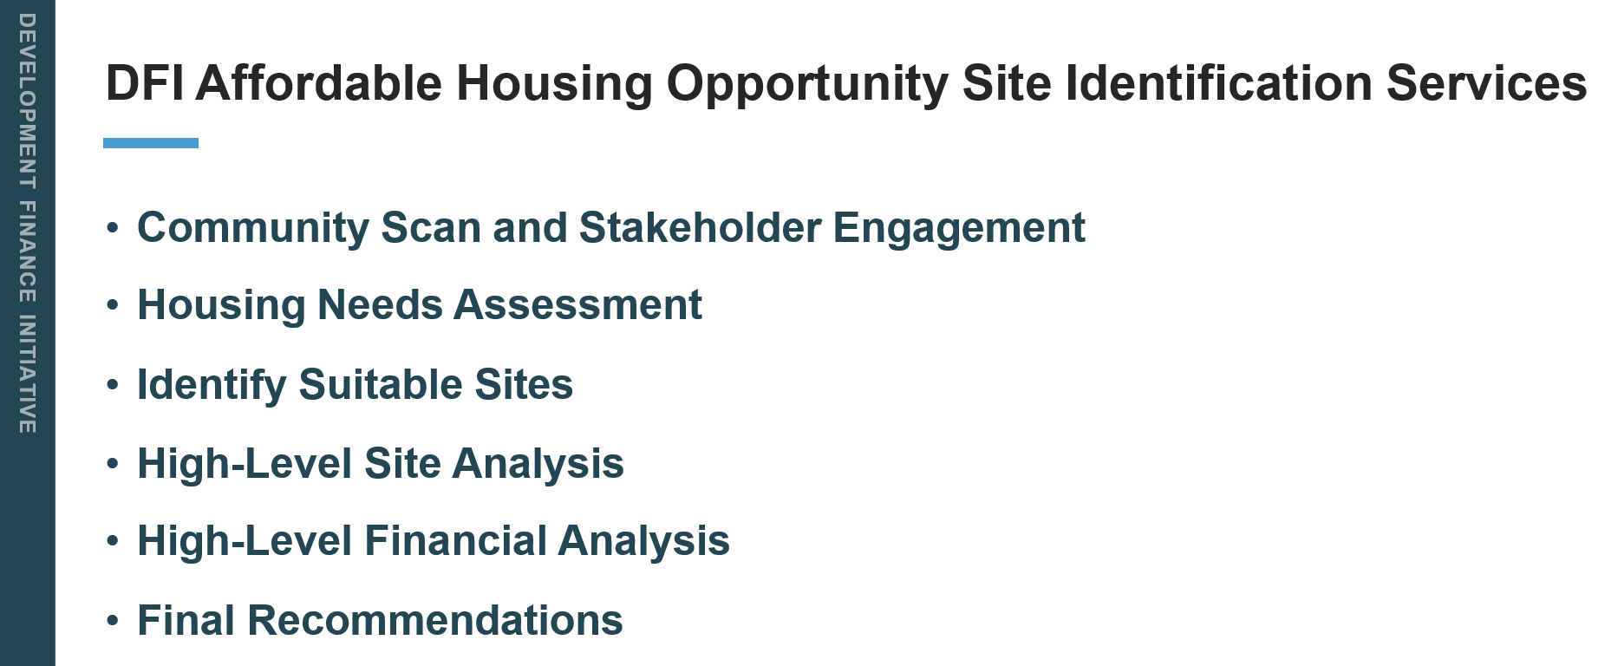

Attorney Beeker added that the Committee has a proposal in their packets in front of them and explained that this is phase one and then if sites are identified then phase two would be for recruiting and trying to find the developer that matches the interest of the public-private partnership. The price is $61,650 (we have a $100,000 grant from the Dogwood Fund) and the way their workload is, they have a lot of irons in the fire right now, but whoever accepts the contract first, they do their work in that order. We are still talking about late August, early September starting time.
Sarah Cosgrove moved, seconded by Madeline Offen, that the city moved forward with the contract with DFI. A unanimous vote of the committee members present followed. Motion carried.

B. Strategic Workhouse Plan – John Connet, City Manager
City Manager Connet turned it over to City Attorney, Angela Beeker passed out an outline to the committee the outlined a plan for moving forward and having an adoption by May of next year. She also set up a field trip for the committees’ next meeting on August 17, 2024. We will charter a bus and leave early in the morning and come back late that evening. That morning we will see some of the DFI sites and then in the afternoon, the Director of the Community Home Trust has agreed to meet with us at the School of Government at UNC Chapel Hill from 2-4 and they will give us a tour and they have developed over 300 units of affordable housing.
The outline showed the following:
Steering Committee
- June, 2024 – DFI Presentation
- July, 2024 – Town of Chapel Hill Presentation
- August, 2024 – Field Trip to Chapel Hill (Community Home Trust & DFI
- September, 2024 – Debrief from Field Trip City Zoning
- October, 2024 – Landlord Tenant Law; Minimum Housing Code; Preserving Existing Stock
- November, 2024 – Section 8 Housing – Housing Authority
- December, 2024 –
- January, 2025 – Draft Goals/Objectives Presented to Committee
- February, 2025 DFI Presentation to Committee
- March, 2025 Draft Plan Presentation to Committee
- April, 2025 – Finalizes Draft Plan to Present to City Council
- May, 2025 –
DFI
- July, 2024 – City Council Approves DFI Contract
- September, 2024 – DFI Begins Work
- October, 2024 – DFI Continues Gathering Data for Needs Assessment
- November, 2024 – DFI Continues Gathering Data for Needs Assessment
- December, 2024 – DFI Presents Needs to Assessment Committee
- January, 2025 – DFI Finishing Work
City Council
- September, 2024 – Council Conversations
- October, 2024 – Council Conversations
City Staff
- December, 2024 – Staff Working on Draft Plan
- January, 2025 – Staff Working on Draft Plan
- February, 2025 – Staff Working on Draft Plan
Community Feedback
- September, 2024 Survey
- October, 2024 – Survey Closes October 31
- November, 2024 – Community Meetings Stakeholder Meetings
- December, 2024 – Community Meetings Stakeholder Meetings
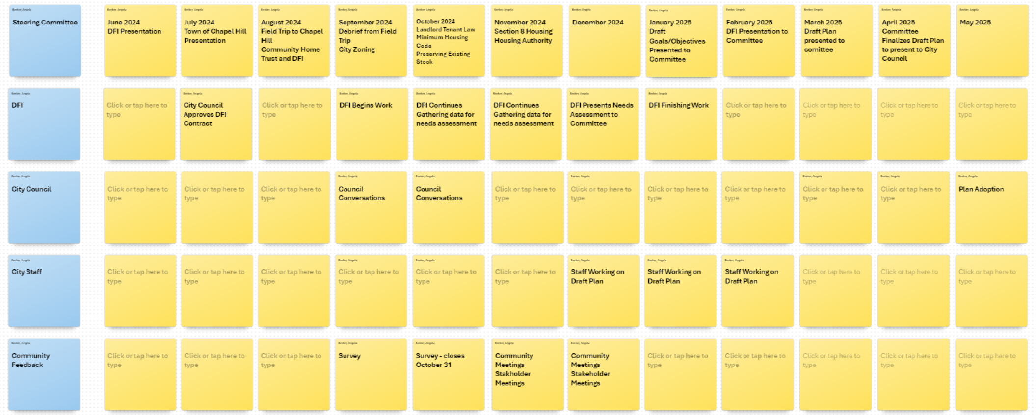
Sarah Cosgrove moved, seconded by Robert Hooper that the committee approve the plan as outlined, including the bus trip to Chapel Hill. A unanimous vote of the Committee Members present followed. Motion carried.

6. OTHER BUSINESS

7. ADJOURNMENT

There being no further business, the meeting was adjourned at 5:05 p.m.

________________________________________________
Jennifer Hensley, City Council Member & Chairman
ATTEST:

_____________________________
Jill Murray, City Clerk

